
Nutrition and Community Health
A Community Service Project report submitted in the partial fulfillment of the requirements forthe award of the degree of
Bachelor of Technology
in
Computer Science and Engineering

Submitted by

S.Mohan Reddy (23761A05P0)
S.Likhitha (23761A05P1)
SK.Atiq Rehaman(23761A05P2)
SK.Maheen(23761A05P3)
SK.Riyaz (23761A05P4)

under the guidance of

Dr.D.Venkata Subbaiah
PROFESSOR

Department of Computer Science and Engineering

LAKIREDDY BALI REDDY COLLEGE OF ENGINEERING
(AUTONOMOUS)
Accredited by NAAC with ‘A’ Grade & NBA (Under Tier - I), ISO 9001:2015 Certified Institution Approved by AICTE, New Delhi and Affiliated to JNTUK, Kakinada
L. B. REDDY NAGAR, MYLAVARAM, NTR Dist, A.P.-521 230.

2025-2026
JULY 2025


LAKIREDDY BALI REDDY COLLEGE OF ENGINEERING
(An Autonomous Institution since 2010) Accredited by NAAC with ‘A’ Grade& NBA (Under Tier - I),
An ISO 21001:2018,14001:2015,50001:2018 Certified Institution
Approved by AICTE,New Delhi and Affiliated to JNTUK,Kakinada
L.B. REDDY NAGAR, MYLAVARAM, NTR DIST., A.P.-521 230.
hodcse@lbrce.ac.in, cseoffice@lbrce.ac.in, Phone: 08659-222 933, Fax: 08659-222931
DEPARTMENT OF COMPUTER SCIENCE & ENGINEERING

Certificate

This is to certify that the community service project entitled “Nutrition and Community
Health” is being submitted by S.Mohan Reddy (23761A05P0) , S.Likhitha (23761A05P1)
SK.Atiq Rehaman(23761A05P2) , SK.Maheen(23761A05P3) , SK.Riyaz (23761A05P4)
in partial fulfillment for the award of B. Tech in Computer Science & Engineering to the
Jawaharlal Nehru Technological University Kakinada is a record of bonafide work carried
out by him/her under our guidance.
The results embodied in this project report have not been submitted to any other University
or Institute for the award of any degree or diploma.

Period of CSP: From: 01-06-2025 To: 13-07-2025

Name & Address of the Community/Habitation:Tummalapalem(village),
Ibrahimpatnam(Mandal),NTR(District),PinCode:521241
Date of Submission:

Project guide Head of the department

Dr.D.Venkata Subbaiah Dr.S.NAGARJUNA REDDY
professor AssociateProfessor & HOD

Student’s Declaration

I,S.Mohan Reddy, a student of BTECH Program, Reg.No.23761A05P0 of the Department of COMPUTER SCIENCE AND ENGINEERING in College do here by declare that I have completed the mandatory community service from 01-06-2025 to 13-07- 2025 in TUMMALAPALEM under the Faculty Guideship of Dr.D.Venkata Subbaiah, Department of COMPUTER SCIENCE AND ENGINEERING in College.

(Signature and Date)

Faculty Guide
Dr . D.Venkata Subbaiah Professor

Head of the Department
Dr.S.Nagarjuna Reddy AssociateProfessor &HOD

Principal
Dr.K.Appa Rao

Student’s Declaration

I,Seelam.Likhitha,a student of BTECH Program, Reg.No. 23761A05P1 of the Department of COMPUTER SCIENCE AND ENGINEERING in College do here by declare that I have completed the mandatory community service from 01- 06-2025 to 13-07-2025 in TUMMALAPALEM under the Faculty Guideship of Dr.D.Venkata Subbaiah, Department of COMPUTER SCIENCE AND ENGINEERING
in College.

(Signature and Date)

Faculty Guide
Dr . D.Venkata Subbaiah Professor

Head of the Department
Dr.S.Nagarjuna Reddy AssociateProfessor &HOD

Principal
Dr.K.Appa Rao

Student’s Declaration

I,Shaik.Atiq Rehaman, a student of BTECH Program, Reg.No. 23761A05P2 of the Department of COMPUTER SCIENCE AND ENGINEERING in College do here by declare that I have completed the mandatory community service from 01- 06-2025 to 13-07-2025 in TUMMALAPALEM under the Faculty Guideship of Dr.D.Venkata Subbaiah, Department of COMPUTER SCIENCE AND ENGINEERING in College.

(Signature and Date)

Faculty Guide
Dr . D.Venkata Subbaiah Professor

Head of the Department
Dr.S.Nagarjuna Reddy AssociateProfessor &HOD

Principal
Dr.K.Appa Rao

Student’s Declaration

I,Shaik.Maheen, a student of BTECH Program, Reg.No. 23761A05P3 of the Department of COMPUTER SCIENCE AND ENGINEERING in College do here by declare that I have completed the mandatory community service from 01-06-2025 to 13-07-2025 in TUMMALAPALEM under the Faculty Guideship of Dr.D.Venkata Subbaiah, Department of COMPUTER SCIENCE AND ENGINEERING in College.

(Signature and Date)

Faculty Guide
Dr . D.Venkata Subbaiah Professor

Head of the Department
Dr.S.Nagarjuna Reddy AssociateProfessor &HOD

Principal
Dr.K.Appa Rao

Student’s Declaration

I,Shaik.Riyaz, a student of BTECH Program, Reg.No. 23761A05P4 of the Department of COMPUTER SCIENCE AND ENGINEERING in College do here by declare that I have completed the mandatory community service from 01-06- 2025 to 13-07-2025 in TUMMALAPALEM under the Faculty Guideship of Dr.D.Venkata Subbaiah, Department of COMPUTER SCIENCE AND ENGINEERING in College.

(Signature and Date)

Faculty Guide
Dr . D.Venkata Subbaiah
Professor

Head of the Department
Dr.S.Nagarjuna Reddy AssociateProfessor &HOD

Principal
Dr.K.Appa Rao

Acknowledgement

The satisfaction that accompanies that the successful completion of any task would be incomplete without the mention of people whose ceaseless cooperation made it possible, whoseconstant guidance and encouragement crown all efforts with success.

We are grateful to our Project Guide Dr.D.Venkata Subbaiah Professor & Dean- Academics Computer Science and Engineering, for the guidance, inspiration and constructive suggestions thathelped us in the preparation of this project.

At the outset we thank our Head of the Department Dr.S.Nagarjuna Reddy and our Honorable Principal Dr. K. Appa Rao for the moral support and the excellent facilities provided. We would also like to thank all the teaching and non-teaching staff members of the Computer Science department.

We wish to express our warm and grateful thanks to people who participated in the survey from Mylavaram for providing the answers in completing our Project successfully.

We thank all our friends who helped us to share knowledge to complete the task in-time.

Name of the Student

S.Mohan Reddy (23761A05P0)
S.Likhitha (23761A05P1)
SK.Atiq Rehaman(23761A05P2)
SK.Maheen(23761A05P3)
SK.Riyaz (23761A05P4)

CONTENTS

SNO | NAME OF THE CONTENT | PAGE NUMBER
1 | EXECUTIVE SUMMARY | 1
2 | OVERVIEW OF COMMUNITY | 2
3 | COMMUNITY SERVICE PART | 3-4
4 | ACTIVITY LOG | 5-16
5 | SURVEY QUESTIONNAIRE | 17-35
6 | DESCRIBING THE SOLUTION | 36-38
7 | REPORT | 39-45
8 | PHOTOS & DETAILS | 46-49
9 | REFERNCE LINKS | 50
10 | MARKS STATEMENT | 51-56

CHAPTER1: EXECUTIVE SUMMARY
We selected kondapalli village to conduct the survey. We travelled through out village and observed each and every part of the village pin point and got known many things like ills and difficulties faced by the residents of the village. Here we interacted with multiple occupations of people like farmers,doctors and senior citizens.
They expressed their views regarding the problems in the village. Here village people are majorly depend on agriculture. Most of they own their agriculture land, but the main problem is salt percentilein water is too high.
Even for both agriculture purpose and domestic purpose they are come across with same saltwater. For drinking purpose they are maintain mineral water tin, which they have to buy daily, which becameburden to lower middle class families.

Our Objectives are:
- Constructing the Health Care Center.
- Establishment of multi-specialty government hospital.
- To assess patient satisfaction with healthcare facilities and services.

- After completion of our project, we got some sought of knowledge about our presentcommunity.
- Use of survey results to inform and guide healthcare policy and decision-making.

CHAPTER 2: OVERVIEW OF THE COMMUNITY

Responses towards my project:
Initially for our community service project we select Tummalapalem as community. Tummalapalem is one of the small town near Vijayawada in NTR. First we dam satisfied with the responses given by the people of Tummalapalem for our project. As we prepared questionnaire related to our project, we made a plan that we want to collect responses to the same questions for same question from different people. We collected responses and made an analysis. Those details briefly included in this document in below section .

Govt Health Centers near Mylavaram
- G.Konduru , Near PACS
- Mylavaram community health center.
- Chevuturu , Near Busstop
- G.Konduru , Rice Mill Street , Near Church
Hospitals near vellaturu. Mylavaram community healthcenter.
Address: 2-293, Near. Sai Baba Temple, Mylavaram.Phone Number: 8659-222269

CHAPTER3: COMMUNITY SERVICE PART

Community Service Project involves students in community development and service activities and applies the experience to personal and academic development. Community Service Project is meant to link the community with the college for mutual benefit.

Conducting a survey:

Step 1: Define the population and sample

Before we start conducting survey research, we already have a clear research question that defines what you want to find out. Based on this question, we need to determine exactly who you will target to participate in the survey.
The target population is the specific group of people that you want to find out about. This group can be very broad or relatively narrow. We decided a village to conduct a survey on agriculture. We mainly focused on farmers in that locality.

Step 2: Decide on the type of survey
There are two main types of survey:
A questionnaire, where a list of questions is distributed by mail, online or in- person, and respondents fill it out themselves. We prepared a google sheet/ Response sheet and madethem to fill it.
An interview, where the researcher asks a set of questions by phone or in person and records the responses. We have prepared a List of Questions and asked to them. All the answers are noted down.

Step 3: Design the survey questions
Next, We decide which questions we need to ask and how we need to ask them.It’s important toconsider:

The type of questions The content of the questionsThe phrasing of the questions
The ordering and layout of the survey

Step 4: Distribute the survey and collect responses
Before we start, we created a clear plan for where, when, how, and with whom we need to conduct the survey. We determine in advance how many responses we require and how we will gain acces ssample.

Step 5: Analyze the survey results
There are many methods of analyzing the results of your survey. First we have to process the data, usually with the help of a computer program to sort all the responses. We should also clean the data by removing incomplete or incorrectly completed responses.

Step 6: Write up the survey results
Finally, when we have collected and analyzed all the necessary data, we have write it up as part of your thesis, dissertation, or research paper.

Then introduced the analysis by describing how we prepared the data and the statistical methods we used to analyze it. In the results section, we summarized the key results from our analysis.

In the discussion and conclusion, we give our explanations and interpretations of these results, answer your research question, and reflect on the implications and limitations of the research.

ACTIVITY LOG FOR THE FIRST WEEK

Day & Date | Brief description of the daily activity | Learning Outcome | Person In- Charge  Signature
Day–1 | On the first day of the week of our community service project, this involved outlining of the key issues to be addressed identifying the target community and establishing we have also discussed about. | Developed skill regarding team maintenance
Day-2 | We discussed about how to identify the problems and how to rectify them in our own perspective. | Developed skill regarding problem detection
Day–3 | We are planned to conduct the survey regarding issues in the village with the help google form. | Developed skill regarding utilization of technology according to our needs
Day–4 | We framed the various types of question’s in different fields in the google form. | Developed skill regarding framing the pattern of questions
Day–5 | We planned how to suggest the solution which satisfies the overall problem | Developed skill regarding problem solving.
Day–6 | We decided to go to the village named kondapalli and planned to conduct the survey over there. | Gained the knowledge about how to conduct the survey

WEEKLY REPORT
WEEK –1(From 01-06-2025 to 07-06-2025)

Objective of the Activity Done: Overall planning for the project and assignment of tasks to the team members
Detailed Report:

Overall, the week was spent getting to know the community,planning the activities. Document your progress throughout the week and reflecton what you have learned.
During the first week of our community service project, we focused on getting to know the community and planning our activities. We are going to spent Monday doing research and making plans for the week. On Tuesday, we going to visit the community center and met with local residents to better understand their needs. Wednesday and Thursday are going to spent conducting our community service activities, which included cleaning up the local park and hosting a youth event. On Friday, we wrapped up our project and reflected on our accomplishments. We were able to make a positive impact in the community and we look
forward to continuing our efforts in the upcoming weeks.

ACTIVITY LOG FOR THE SECOND WEEK

Day & Date | Brief description of the daily activity | Learning Outcome | Person In- Charge  Signature
Day–1 | We have started the second week of our community service project by making a note of the locality, as soon as we went to Tummalapalem we have observed the people over there. | We have learnt the grasping skills
Day-2 | The next day we visited the Agriculture fields of Tummalapalem and we have seen a group of farmers working hard in the field. | We have learnt the importance ofteamwork.
Day–3 | On the third day of second week we went to observe the hospitals and health care centers of Tummalapalem, And we have made a notice of how patients were treated. | We have improved observation skills.
Day–4 | The very next day we noticed the chores of house wives. | We have developed Organization and time management skills.
Day–5 | On the fifth day of the week we visited A school of Tummalapalem and we have noticed that school in all aspects for example like Education  ,hygiene and much more. | We have learnt classroom management skills and we also improved our time management skills.
Day–6 | We have ended the week by making are port on the aspects we observed in Tummalapalem. | We have developed the skill of outline a report.

WEEKLY REPORT
WEEK –2(From 08-06-2025 to 15-06-2025)

Objective of the Activity Done: Observing the locality
During the second week of our community service project,we mainly focused on observing the locality of Mylavaram , on the first day we made a notice on roads of Mylavaram and the very next day we have visited agriculture fields of that locality and we have seen a group of framers working hard together and helping each other through that we understood the importance and the strength of the team work . On the third day of the week we visited health care center and we have seen how the patients were treated and we have came to know that there is only one health care center in the particular locality and we have seen each and every person patiently waiting for their turn to get treatment by that we have improved our patience skills and observation skills ,and the next day that is fourth day of the week we made a notice on women working at home we observed that they are performing their chores perfectly through that we have developed our organization and time management skills ,and on the very next day we have Visited the school in Tummalapalem and we made a notice on many aspects related to that school like how the teachers were teaching
,what are the teaching their students, how they were maintaining discipline within students, and we also made a note on hygienic levels of schools and through this we have learnt classroom management skills and we have also developed critical thinking and on the last day of week we made a report related to above aspects and through this we have learnt how
to outline a report.

ACTIVITY LOG FOR THE THIRD WEEK

Day & Date | Brief description of the daily activity | Learning Outcome | Person In- Charge  Signature
Day–1 | We started interacting with people all over the village. Some people rejected to interact with us & some are responded well. | Developing skill regarding communication.
Day-2 | We went to primary health care center in the village which was handled by government as some of patients about the facilities over there. | Developing skill regarding adopting to particular situation.
Day–3 | We reached cotton field and interacted with farmers over there and noted their daily routine. | Developing skill regarding patience listening.
Day–4 | We interacted with an RMP doctor who changed his occupation to an shopkeeper and got known the reasons regarding his change. | Developing skill regarding how to handling the situation during toughtime
Day–5 | We interacted with residents all over the village and asked about their livelihood and daily routine. | Developing skill regarding sustainable life
Day–6 | We prepared a final report summarizing the activities undertaken during the two-week community service project and outlining recommendations for ongoing improvements in health services. | Developing skills in report writing and summarizing project outcomes

WEEKLY REPORT
WEEK –3(From Dt 16-06-2025 to 22-06-2025)

Objective of the Activity Done: Interacted with different fields of people and got known they livelihood
Detailed Report:
During the third week of our Community Service Project (CSP), we focused on conducting a detailed knowledge about the livelihood of the people all over the village in the rural village of Mylavaram in Andhra Pradesh, India. The interaction was conducted through a combination of methods, including interviews, observations, and secondary data analysis.

Through our interaction, we interacted with different occupations of people and listen their livelihood and understand their situation and task of their life. We identified that some are changed their occupations due to problems over their. Some people are facing problems due to lack of hospitals and suffering with some common communication diseases.
Overall, the third week of our CSP was crucial in identifying the health challenges facing the rural community of Mylavaram. Through our report, we were able to develop actionable recommendations that can help improve the living conditions of the community in the short term .

ACTIVITY LOG FOR THE FORTH WEEK

Day & Date | Brief description of the daily activity | Learning Outcome | Person In- Charge Signature
Day–1 | We asked people in the village about the transportation problems they faced while going to the nearby hospitals. | Developing the skills in problem  identification.
Day-2 | We knew that ,Recently They established a health care centre which needs lot of development . | Understanding the importance of on- site observation.
Day–3 | The people in the community expressed that medicines are expensive than MRP.People suffered a lot due to lack of proper health facilities. | Developing the skills of understanding the problem.
Day–4 | There was less amount of ground water in that area, which leads to insufficiency to agriculture fields. | Developing the skill of effective analyzing the problem statements.
Day–5 | We observed that there are many problems faced during reaching the hospital and surveyed about their jobs. | Understanding the situations of the places we visited.
Day–6 | Less payment for daily wage workers. More working hours and less facilities are provided. Low employment opportunities. | Developing the skill of visualizing of the challenges faced by the people.

WEEKLY REPORT
WEEK –4(From 23-06-2025 to29-06-2025)

Objective of the Activity Done: Interacted with people and find the difficulties faced by the people
Detailed Report:
On the fourth week of the community service project we mainly concentrated on the challenges faced by the people in the village. We came through many problems faced by the Community. Major problems are faced while reaching the hospital. They need transportation facility.
Health facilities does not meet up their needs. Proper medication and sanitization required for the maintenance of health. We know that “Health is Wealth”. But there are no health care centers in that area for past few years. Recently they established a primary health care center which needs to be developed to reach the requirement of people. Medicines are essential to every individual But medicines are very expensive, which can’t be affordable by that villagers. Hence medicines are not budget friendly.

ACTIVITY LOG FOR THE FIFTH WEEK

Day & Date | Brief description of the daily activity | Learning Outcome | Person In- Charge Signature
Day–1 | The first problem we identified in the village after interacting with people is they need good transportation facility to reach the nearby hospital on-time. | We have learned that they need good transportation facility.
Day-2 | The next problem major problem of the village is lack of health care centers as per our survey we found only one health care center in the village with the least facilities and solution for that could be conducting medical camps and constructing a  hospital . | We have came to know that conducting medical camps can help people in rural areas
Day–3 | We have came to know that there are lesser no of RMP doctor are available in the village. | We have came to know that there are less number of medical facilities.
Day–4 | Another major problem related to this particular village is no education is provided regarding health. They need a good education on the different health issues and the prevention that we can do before it gets serious. | We have learnt about many health issues and possible prevention ways for it.
Day–5 | We have identified that there were no medical camps were getting conducted recently. | We have learnt about medical camps.
Day–6 | Another problem we observed in the village are Roads are unhygienic . | We understood the importance of hygiene

WEEKLY REPORT
WEEK –5(From 30-06-2025 to 06-07-2025)

Objective of the Activity Done: : Solutions for the issues faced by0020villagers
Detailed Report:
During the fifth week of our community service project we mainly focused on providing solutions for the complications that are faced by the people of Mylavaram. After interacting with the people of village we came know about major issues that are troubling the people are The first problem we identified in the village after interacting with people is they need good transportation facility to reach the nearby hospital on-time. The next problem major problem of the village is lack of health care centers as per our survey we found only one health care center in the village with the least facilities and solution for that could be conducting medical camps and constructing a hospital.

We have come to know that there is lesser no of RMP doctor are available in the village. Another major problem related to this particular village is no education is provided regarding health. They need a good education on the different health issues and the prevention that we can do before it gets serious. We have identified that there were no medical camps were getting conducted recently. Another problem we observed in the village are Roads which are unhygienic.

ACTIVITY LOG FOR THE SIXTH WEEK

Day & Date | Brief description of the daily activity | Learning Outcome | Person In- Charge  Signature
Day–1 | We are planned to conduct the different awareness programs all over the village regarding the generalized issues in the village. | Developing skill in conducting awareness programs.
Day-2 | Awareness programme about the importance of being hygiene and keeping our surroundings clean. | Developing skill regarding programme organization.
Day–3 | Awareness programme about using the Telehealth care services, Explaning it advantages and getting known it effectiveness. | Developing the skill regarding learn and let everybody learn.
Day–4 | Awareness programme about communicable diseases and how to break that chain between person to person. | Developing the skill regarding communication and behavior.
Day–5 | Awareness programme about implementation of Drip irrigation method, on which way we can minimize the usage of water. | Developing skills in community mobilization and participatory decision- making.
Day–6 | We prepared a final repo summarizing the activities undertaken during the six- week community service project and outlining recommendation for ongoing improvements in health. | Developing skills in report writing and summarizing project outcomes.

WEEKLY REPORT
WEEK –6(From 07-07-2025 to 13-07-2025)

Objectiveof the Activity Done: Conduct community awareness programs on water and sanitation
Detailed Report:
we conducted community awareness programs on water and sanitation in the rural village of Mylavaram The programs were designed to educate and raise awareness among community members about the importance of clean water and health and well- being.

We organized several interactive sessions with community members, including men, women, and children, to discuss various issues related to water and health. We also distributed informational materials, such as brochures and flyers, that provided tips on how to maintain good health and conserve water.

The programs were well-received by the community, and we observed a significant improvement in their knowledge and attitudes towards water and health Community members expressed their appreciation for the informative sessions and the materials we distributed.

Based on the success of these programs, we recommend that similar awareness programs be conducted regularly in rural communities to educate and raise awareness among community members about the importance of health and pure +water. We also recommend that government and non-governmental organizations invest in the development of infrastructure and resources to improve access to clean water and health care facilities in rural areas.

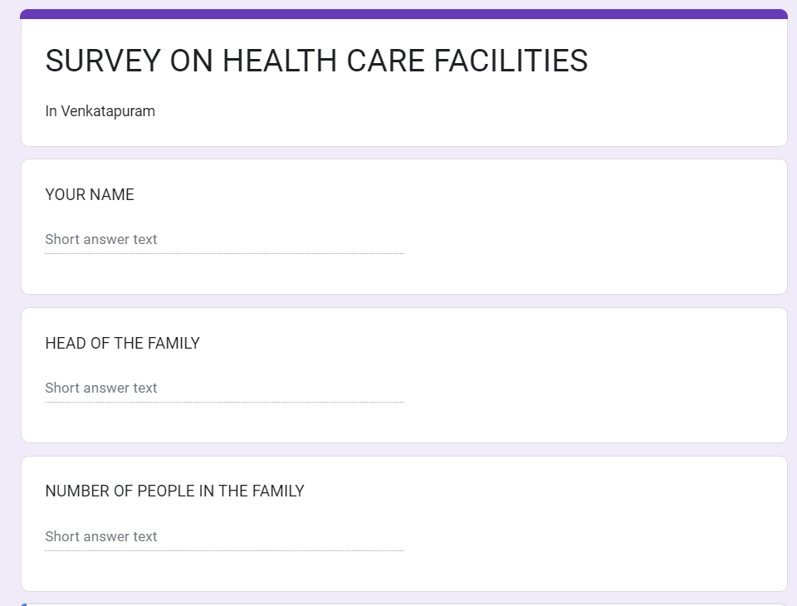
.

CHAPTER5 : OUTCOMES DESCRIPTION SURVEY QUESTIONNAIRE:

The following survey questionnaire was designed with an aim of generating data related to people Perception on facing the health care facilities. The respondents were asked to fill the questionnaire. Questions were framed in logical order and were of different types. Few are a short answer where as few are rating scales. This diversified approach while framing the Survey questionnaire helped us in collecting the data in an easier format without much chaos. It must be noted that the responses are entirely based on the perception of the respondents.

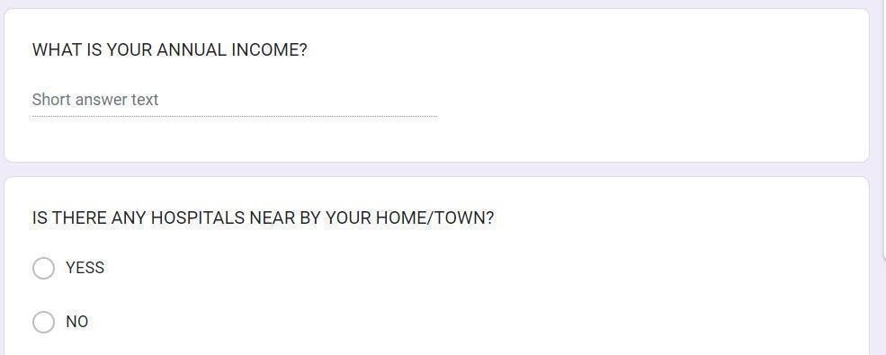
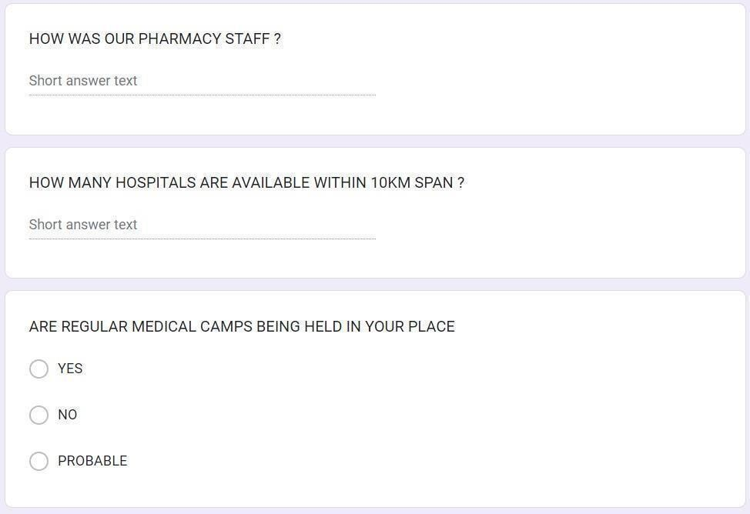

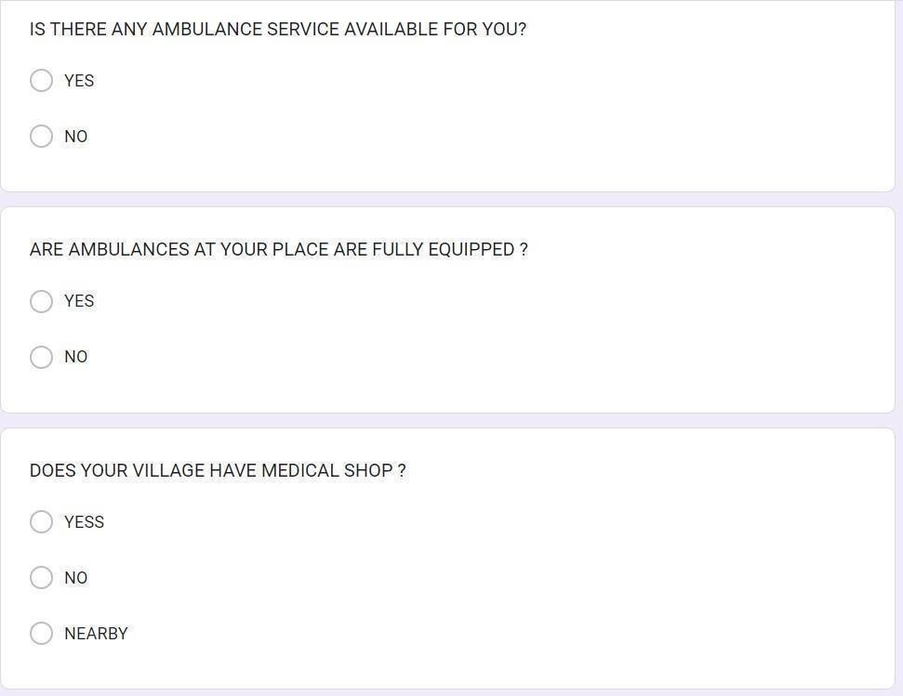
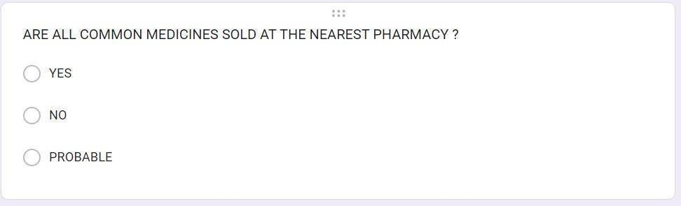
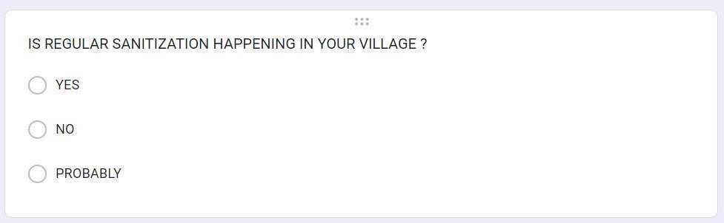

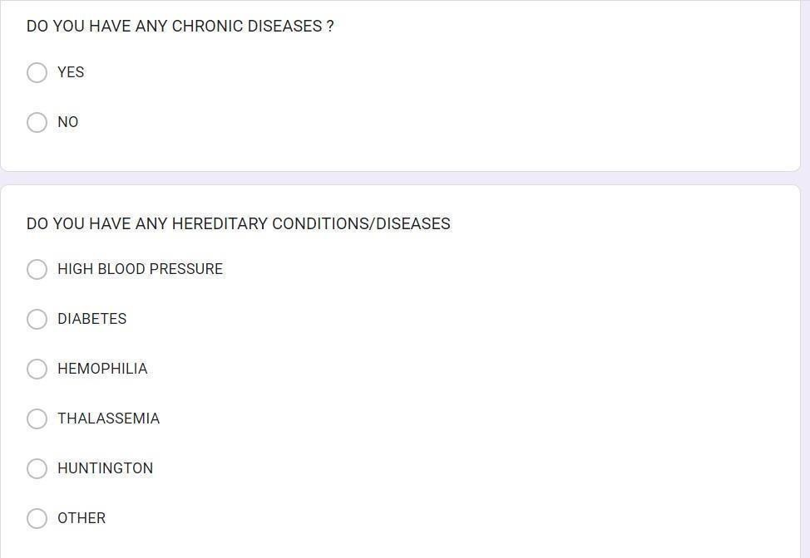
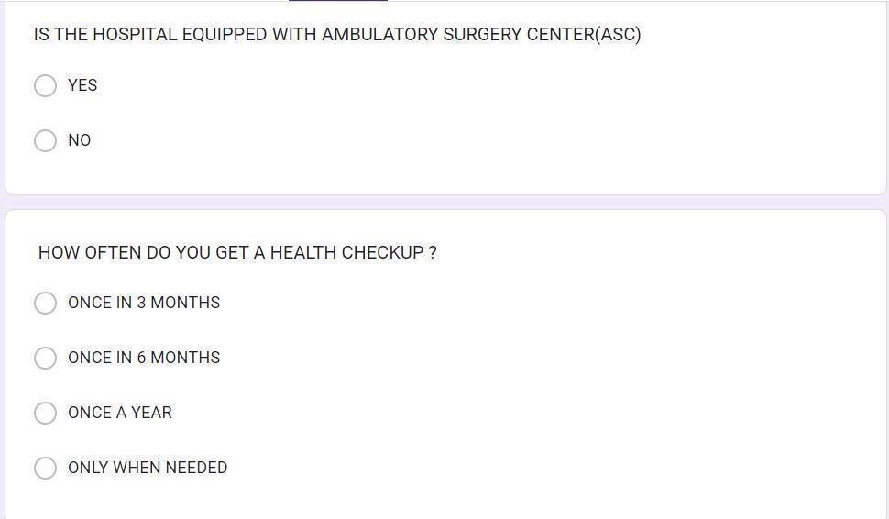

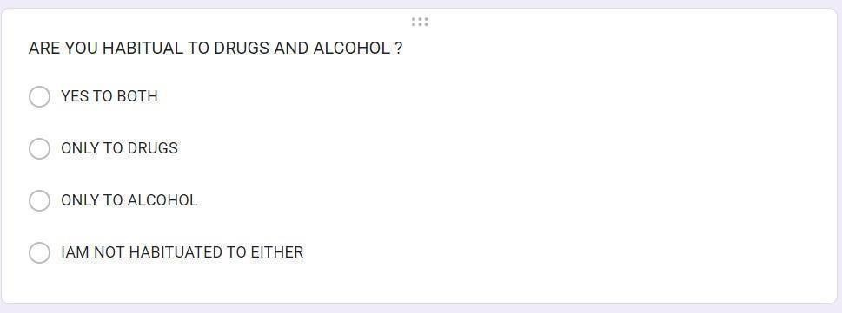
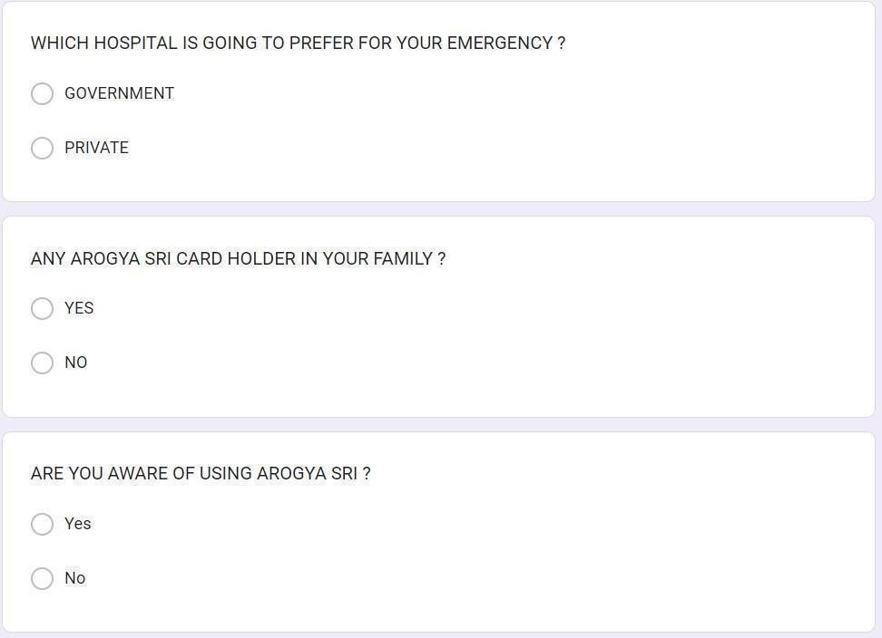

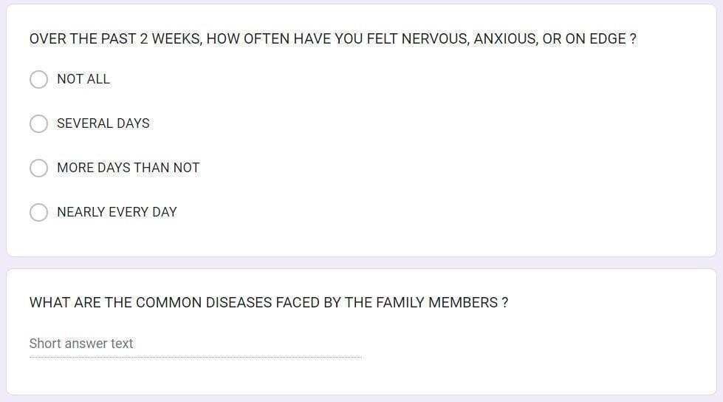
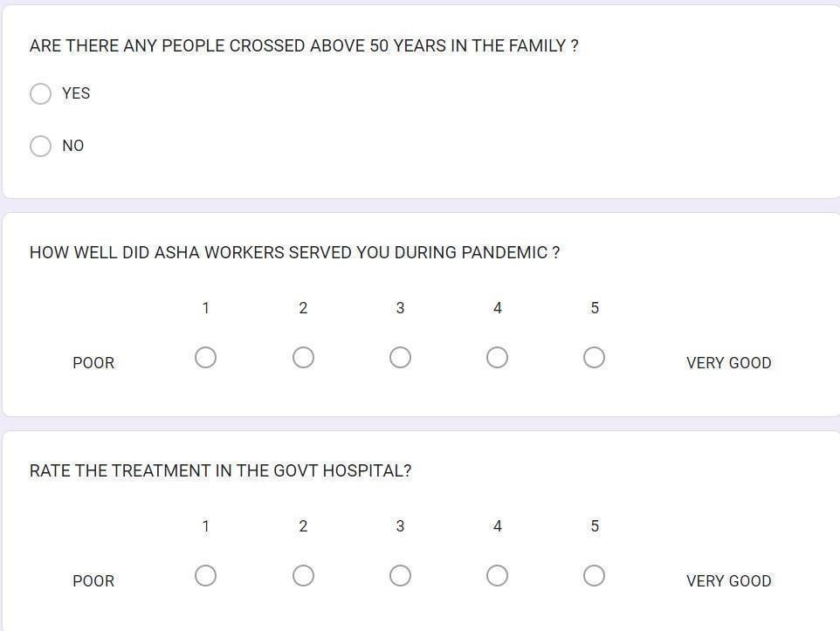

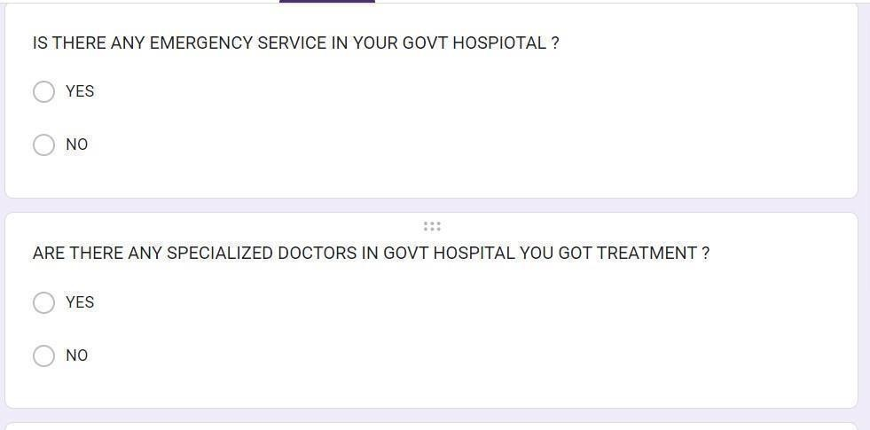
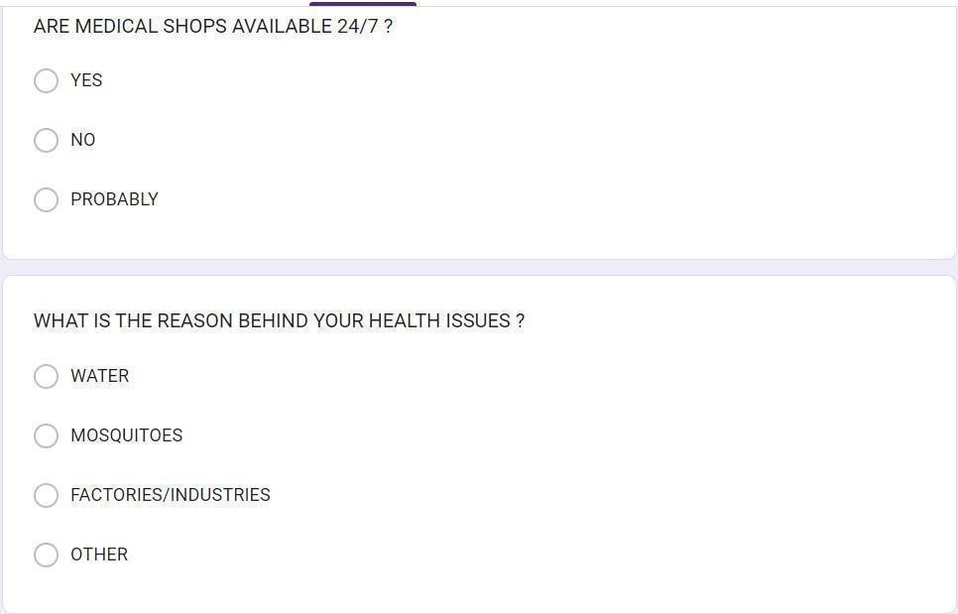
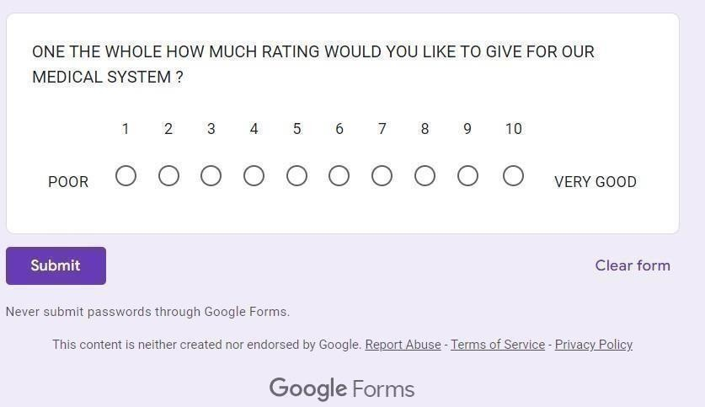

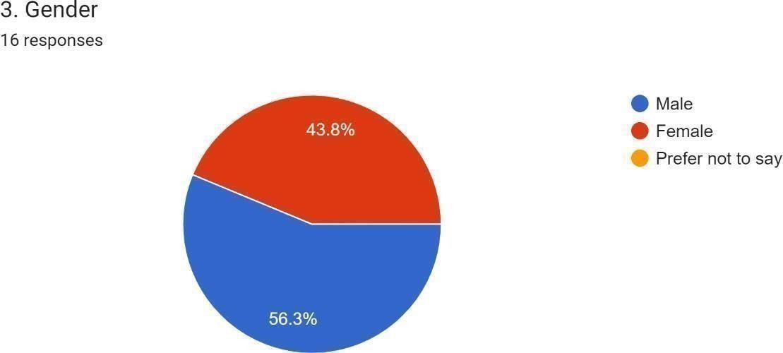
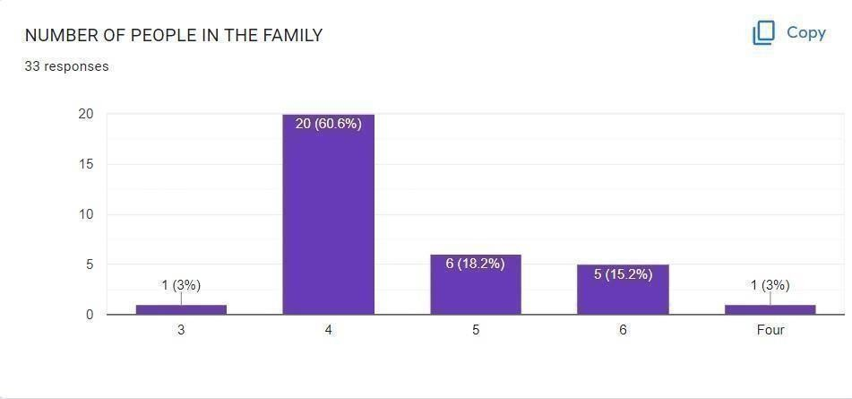
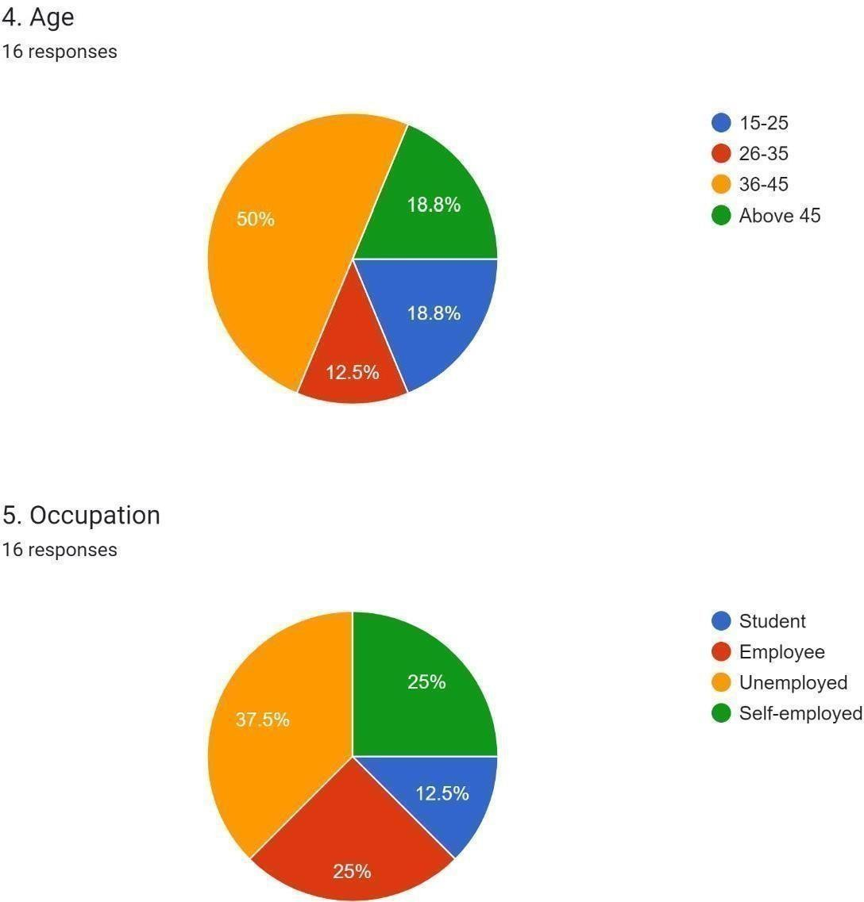
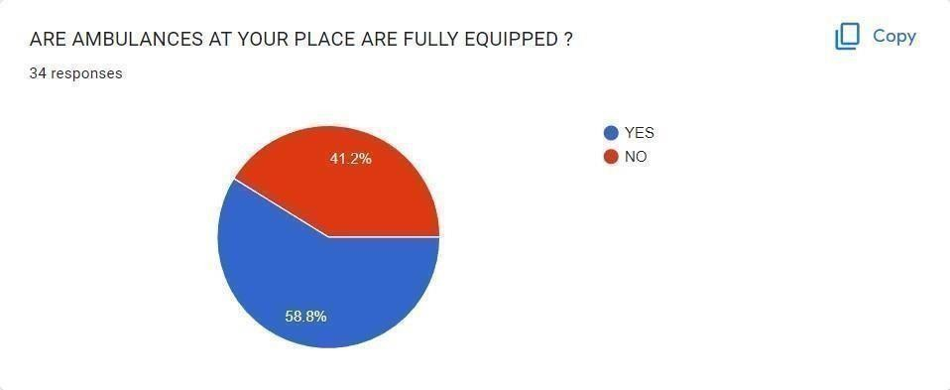
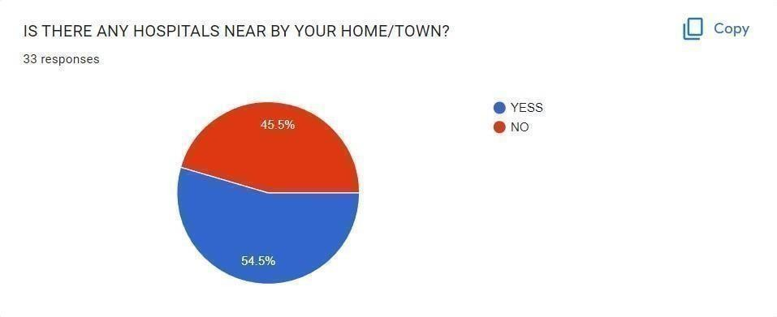
CSP
Responses

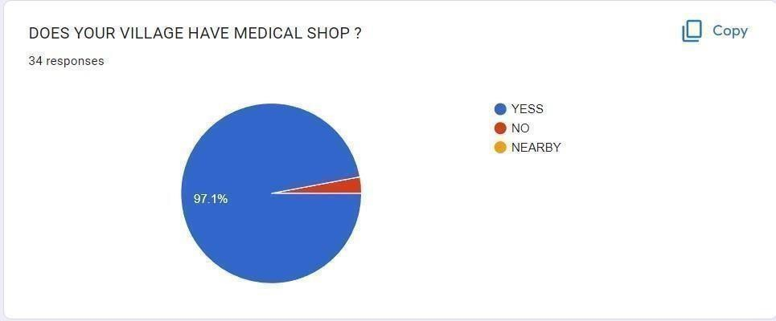
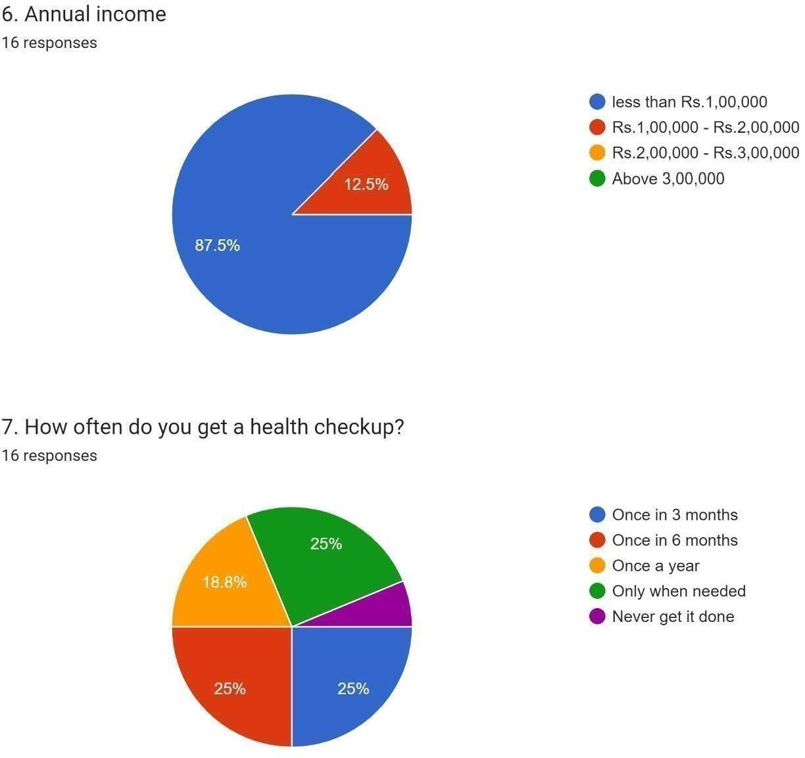
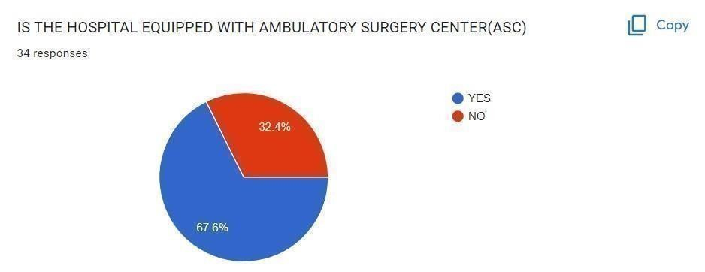
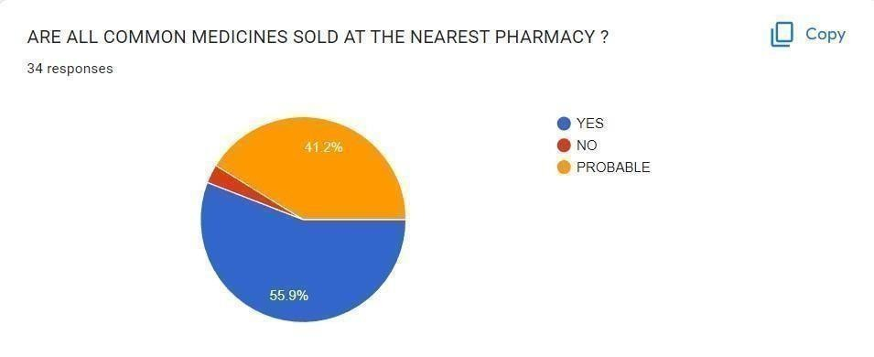

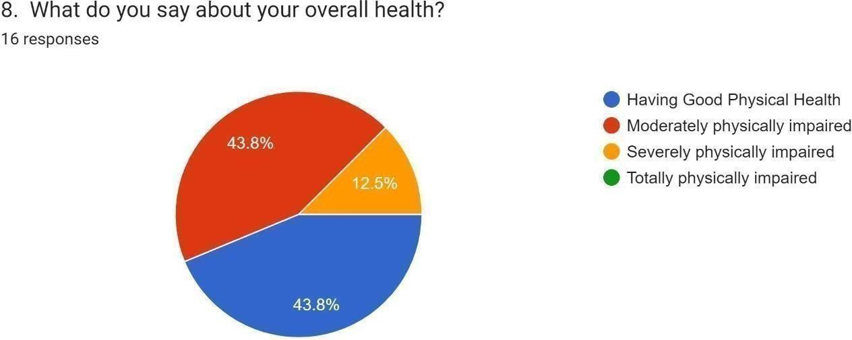
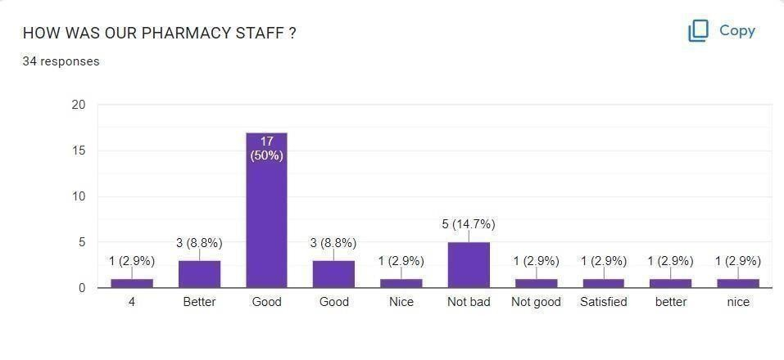
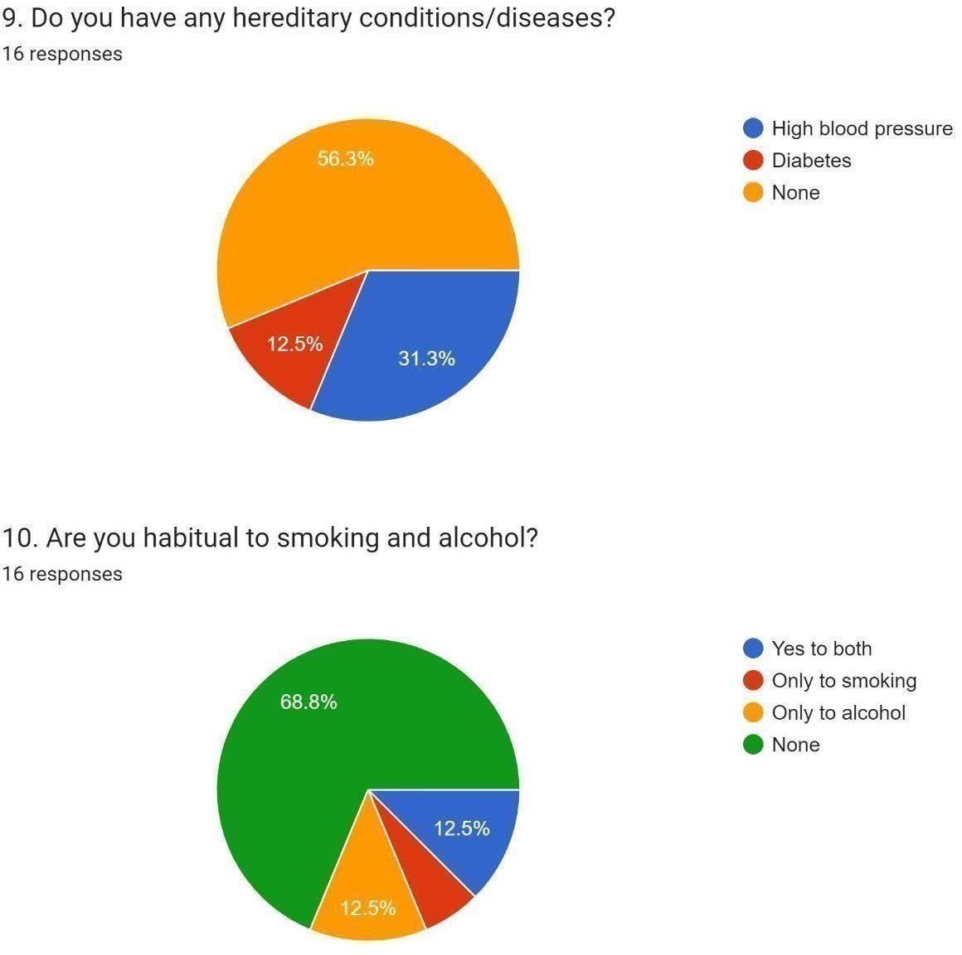
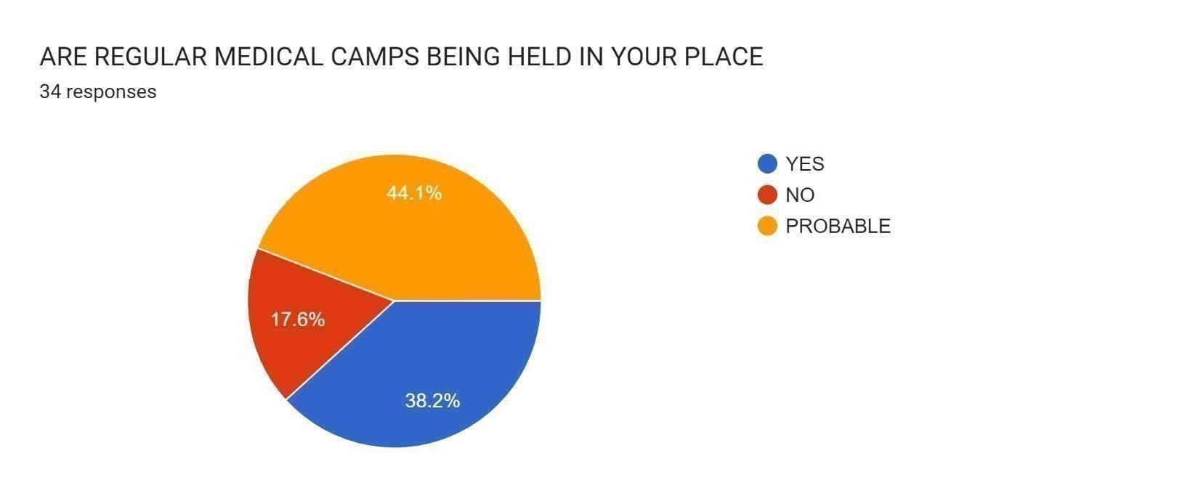
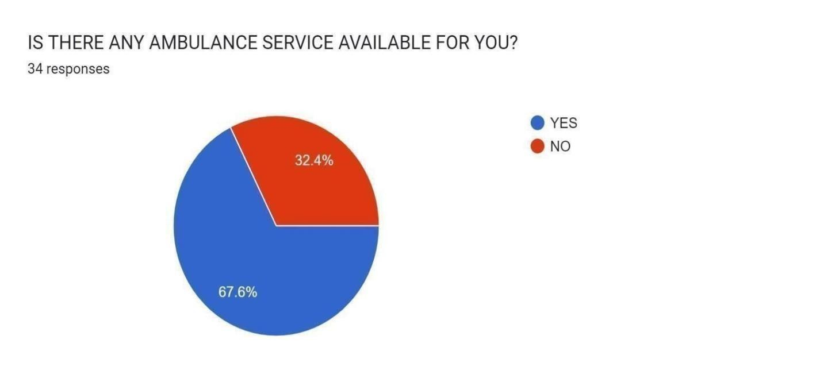

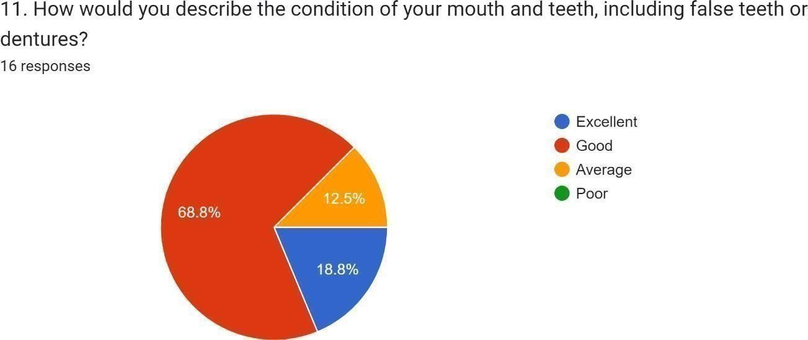
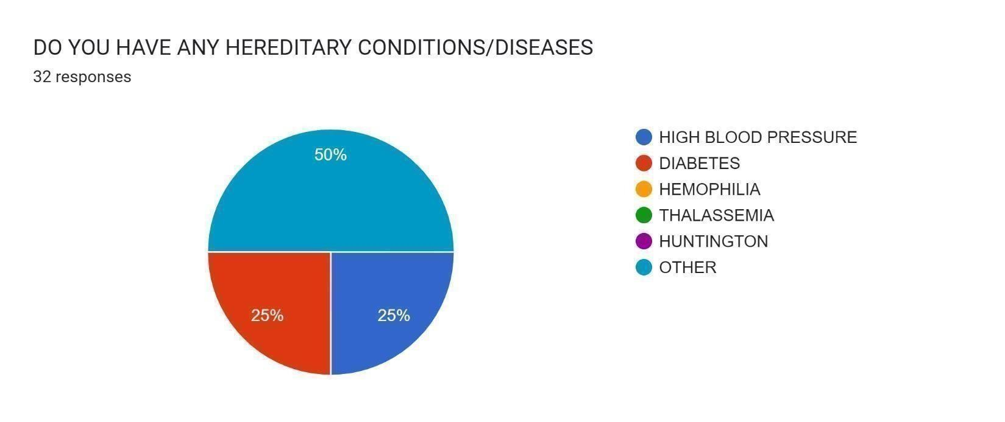
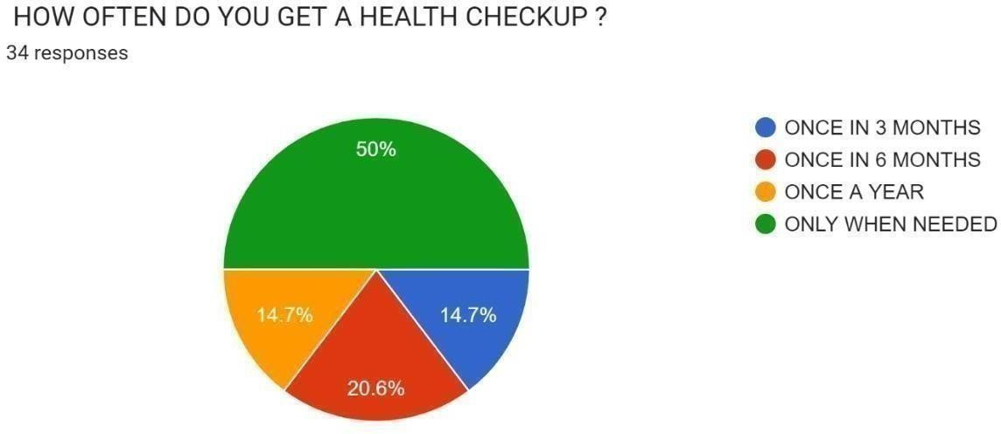
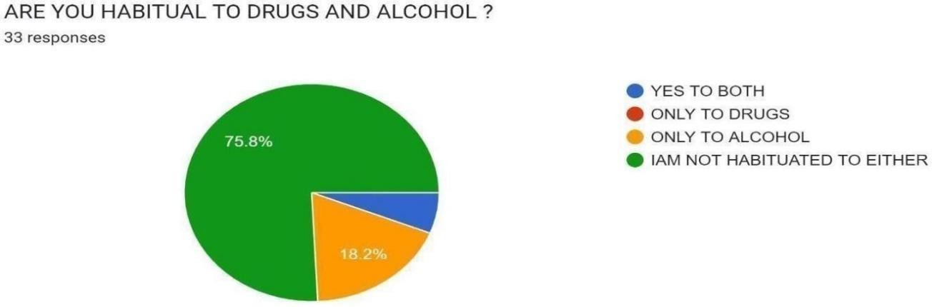

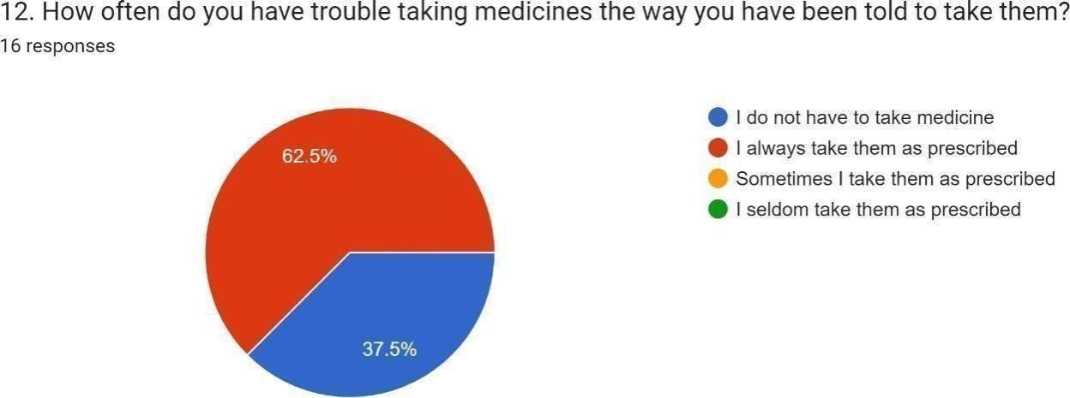
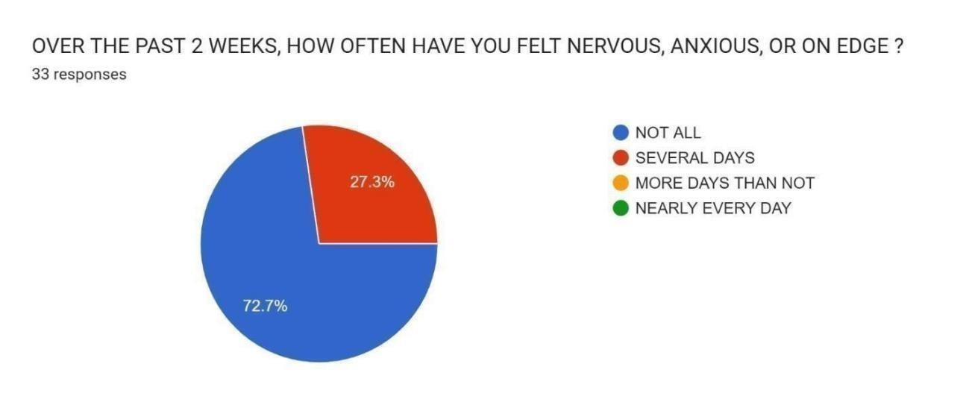
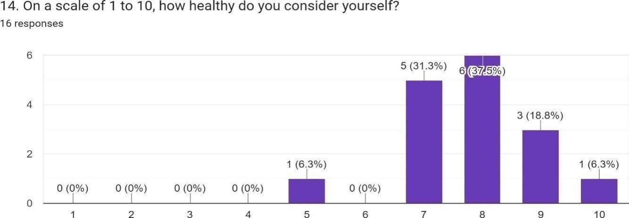
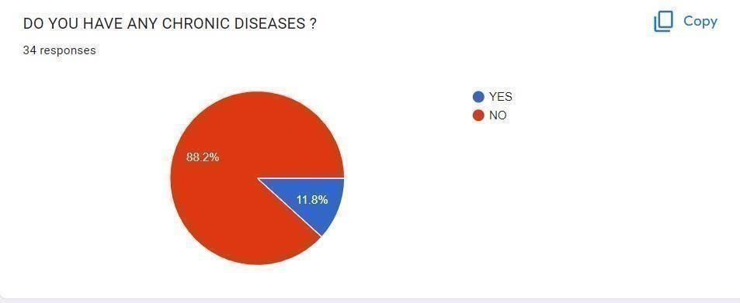
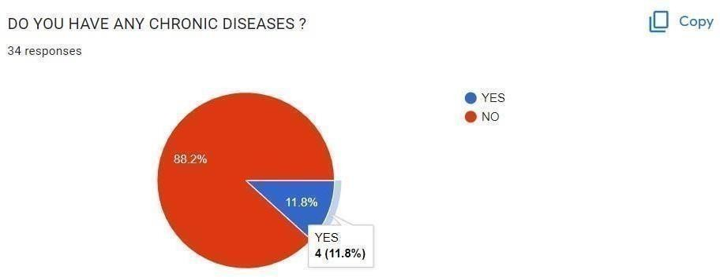

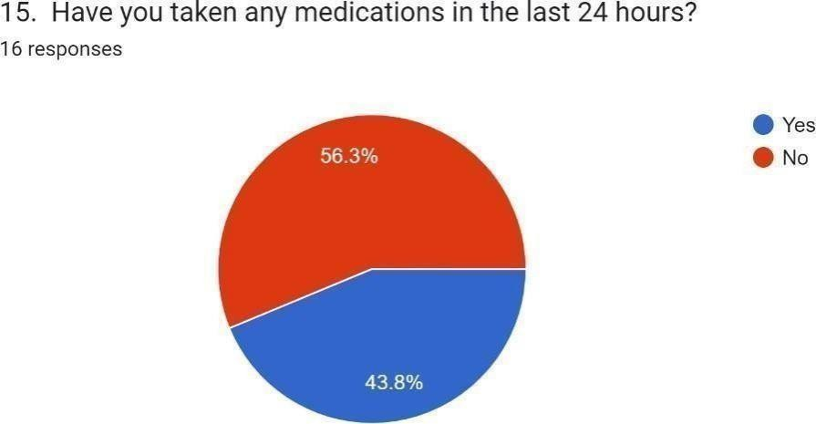
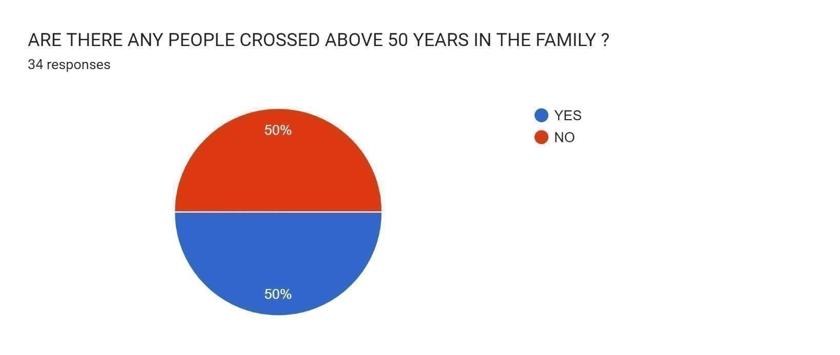
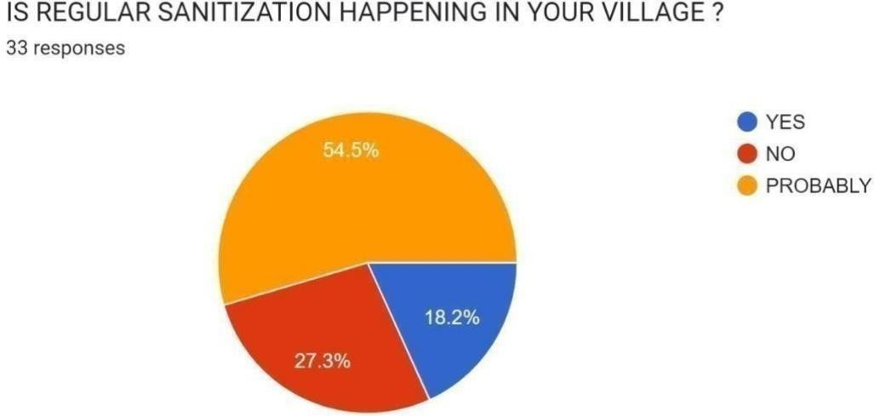
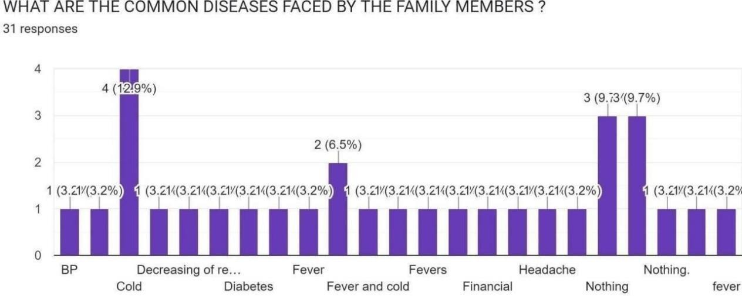

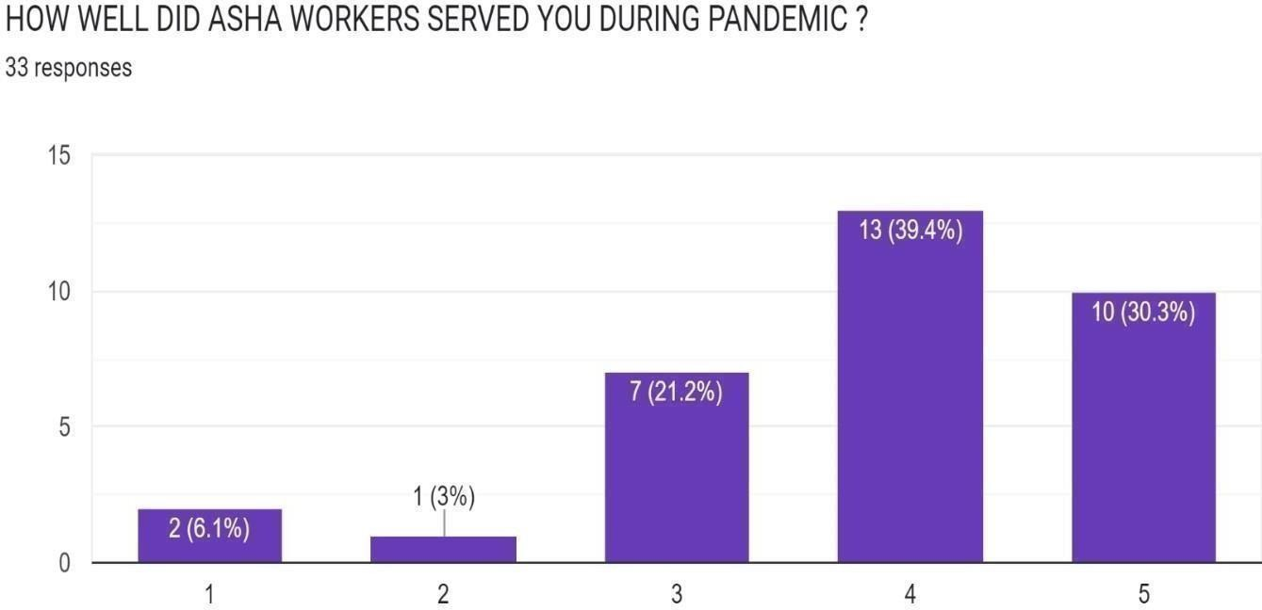
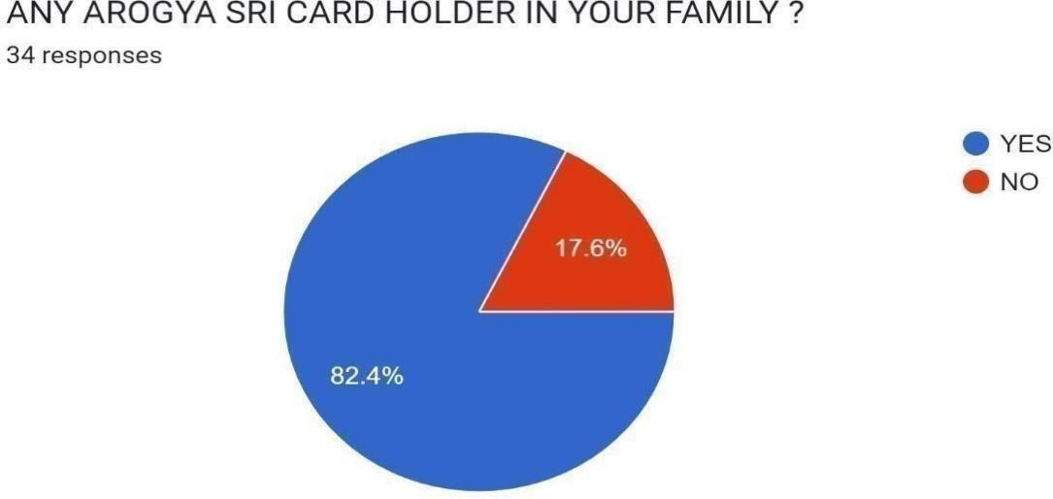
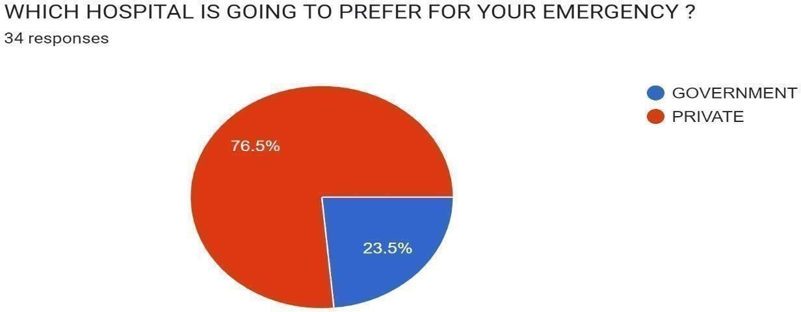

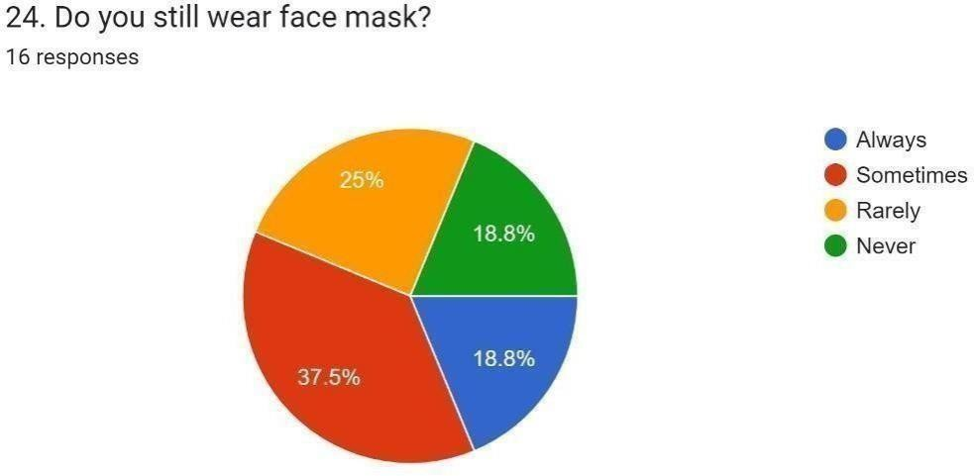
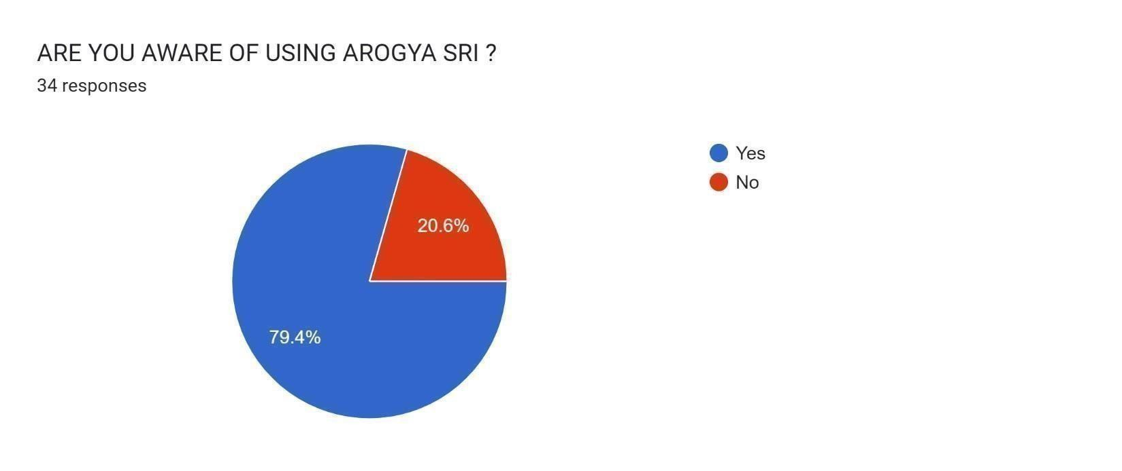
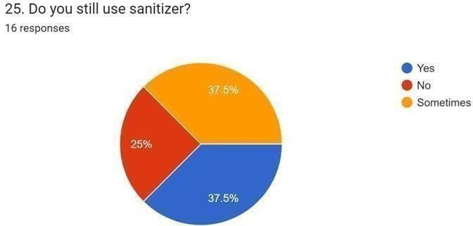
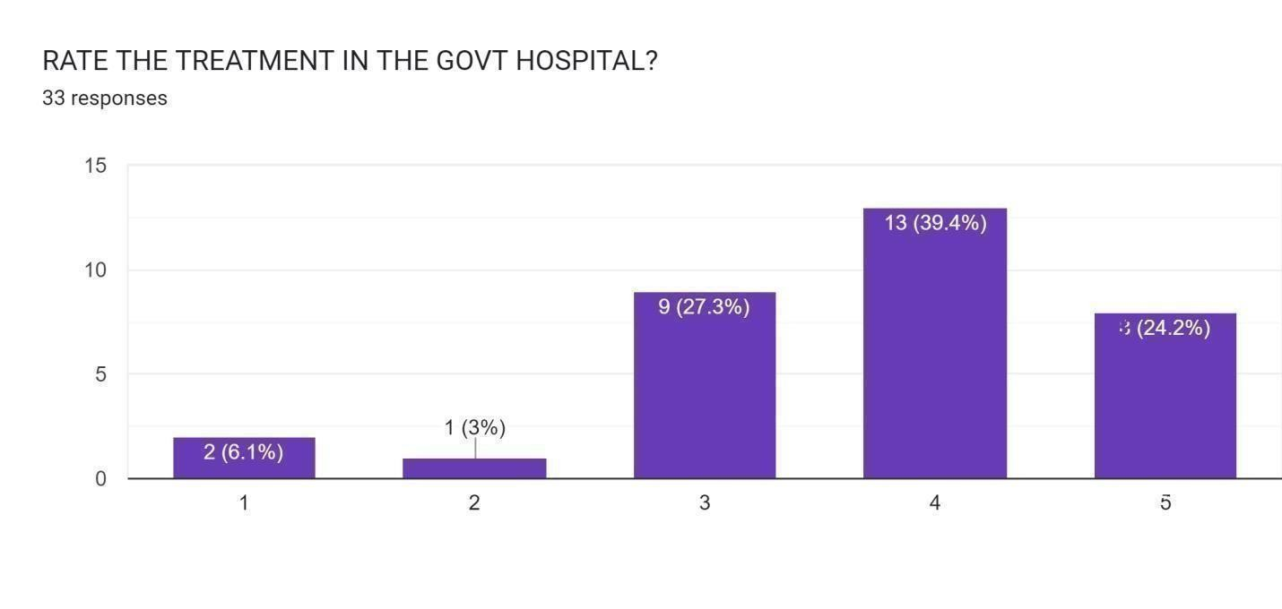
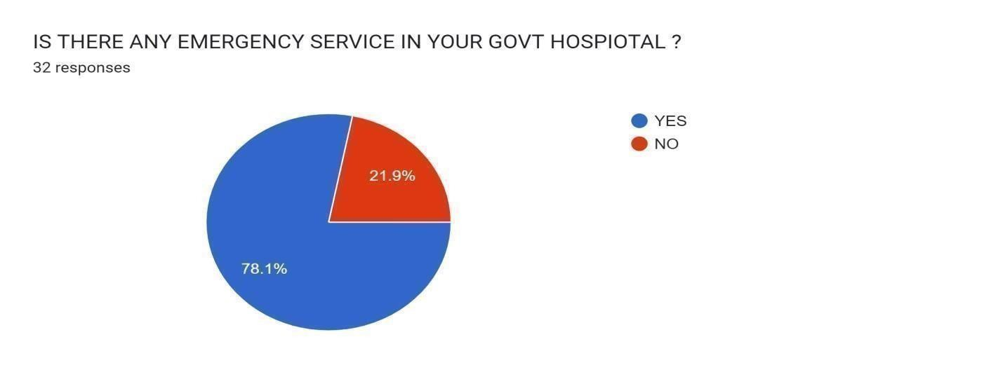

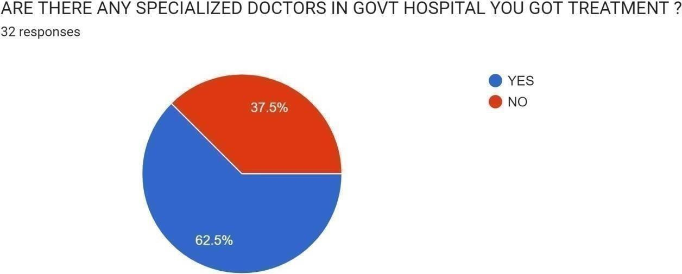
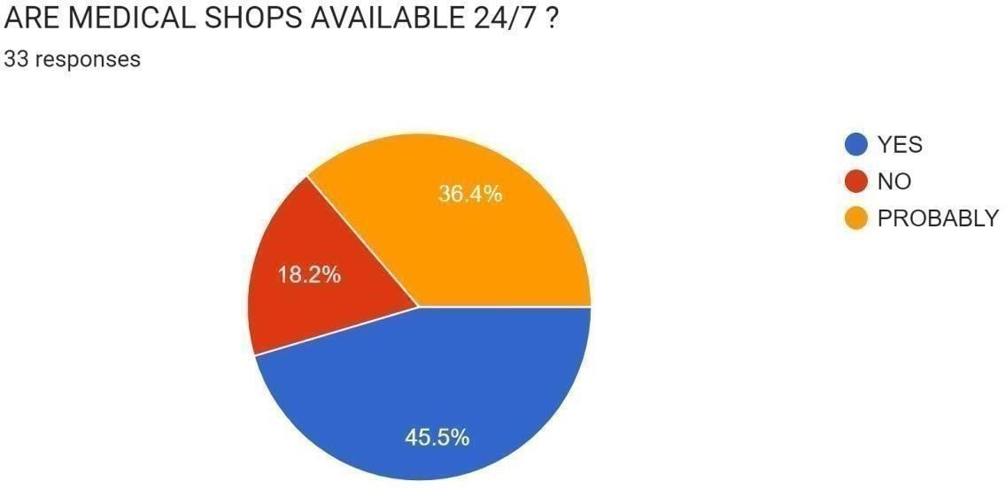
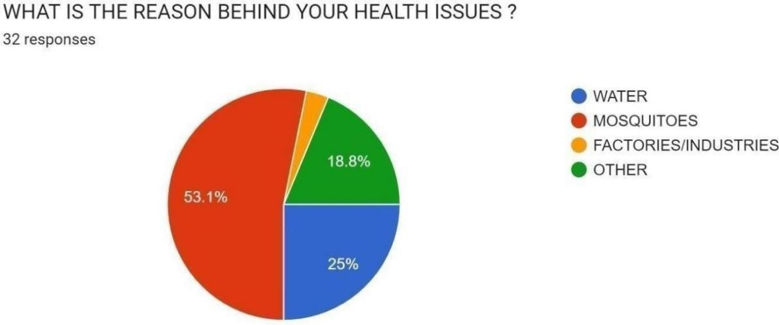


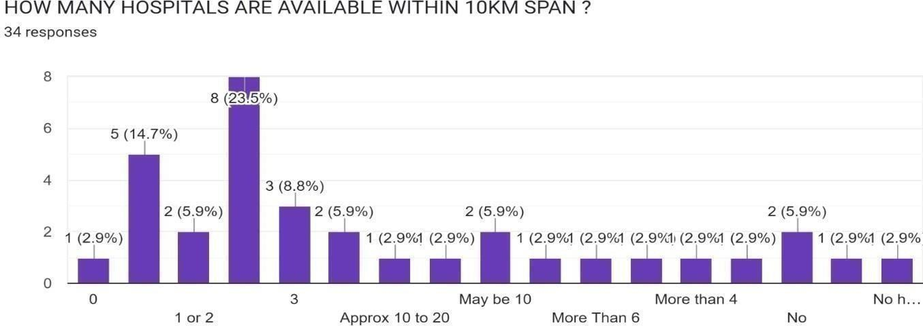
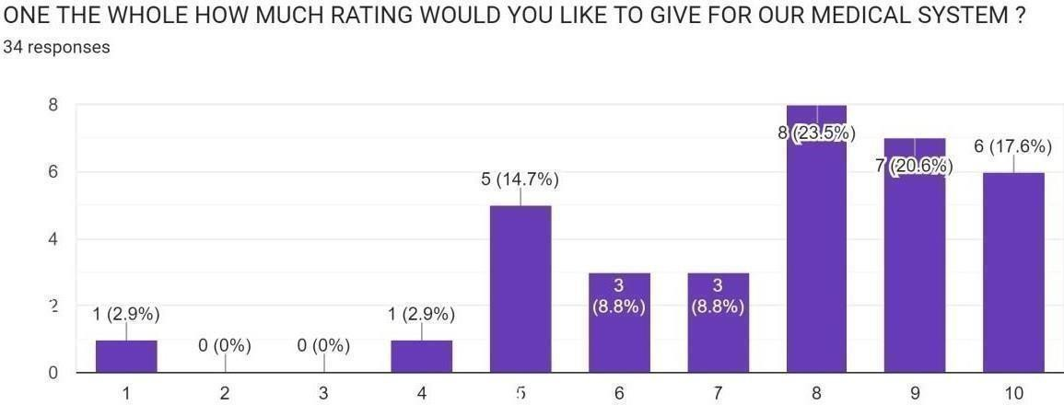

Describe the problems you have identified in the community

- lack of health care center’s

Lackof Health Care Centers :

The progress and development of our country depend on the improved living conditions in rural areas where all the meaningful life supportive facilities, including healthcare facilities, will be adequately available for one and all. The places in Indian villages are surrounded by poverty, diseases, as well as lack of cleanliness. Due to a lack of facilities and improper management in rural areas, people living in villages may suffer a lot due to various diseases.

Healthcare is not only for affluent people, but it's the right of every single person. However, the lack of better infrastructure on qualitative terms, lack of accessibility to medical facilities and medicines required in daily life and the scarcity of qualified medical specialists have prevented the healthcare facilities from reaching 60%of the Indian population. Medical facilities are mostly deplorable in village areas. Quality healthcare services must reach every village, and everyone must get these benefits irrespective of financial condition.

Short-term and long-term action plan for possible solutions for the problems identified and that could be recommended to the concerned authorities for implementation.
for lack of health care centers Short term solution:
Rural medical camps
To control the spread of diseases and reduce the growing rates of mortality due to lack of adequate health facilities, special attention needs to be given to the health care in rural areas. The key challenges in the healthcare sector are low quality of care, poor accountability, lack of awareness and limited access to facilities.It should include educating people to work towards building an environment of well-being by proper sanitary habits and explain how they can bring a difference at community level.

Long-term solution:

Construction of multi-speciality Hospitals in ruralareas What is a Multi-Speciality Hospital?
A Multi-speciality Hospital is one that has facilities for all ailments and diseases with an expert team of doctors and specialists. The patients are so immensely taken careof with air-conditioned rooms and canteens inside and personalized care.

Five Reasons to Choose a Multi Speciality Hospital:

Easy Treatments,
Larger teams with Multiple Specialities:
Varied Equipment available Under One Roof:
Treating Different Lifestyle Diseases Simultaneously: Better Integration With Insurance Companies:

Description of the Community awareness programmes conducted w.r.t the problems and their outcomes.

Awareness about communicable diseases:
After the pandemic situation, cold and cough became the common diseases inour day to day life
. We are neglecting those type of diseases and not at all taking some preventive measures. We haveto remember that they are communicable disease and wehave break the chain of transmission. Even if we affected with common cold also, we have to treat it as atmost care and always remember that Prevention is better than cool.

Necessary of Being Hygiene:
Most of the seasonal diseases like Typhoid, Malaria, Dengue etc are mostly caused by some insects like mosquitoes and others. These insects are mostly survive in the place where there is lack of cleanliness. So to avoid such diseases we have to keep our surrounding clean and hygiene.

Utilization of Tele-Health care services:
People in rural areas suffers for health consultation issues due to lack of necessary no of doctors. Even if they go and consult doctor, the hospital is crowded andit takes lots of time to get treated. So we recommend the people all over the village to utilize the telehealth services. They can consult doctors in their home itself with relaxedmode, so that they can minimize the to get struck in crowd. Telehealth services are 24 hours available.

Report of the mini-project work done in the related subject w.r.t
the habitation/village.

Major Problems of Health Services in India
After Independence there has been a significant improvement, in the health status of people.But the situation is not much better as per study of WHO. It has placed India in 112th position among 191 countries of the world.Even Bangladesh is ahead of India.

The following are the major problems of health services:

- Neglect of Rural Population:
A serious drawback of India’s health service is the neglect of rural masses. Itis largely a service based on urban hospitals. Although, there are large no. of PHC’s and rural hospitals yet the urban bias is visible. According to health information 31.5% of hospitals and 16% hospital bedsare situated in rural areas where 75% of total population resides.

Moreover the doctors are unwilling to serve in rural areas. Instead of evolving a health system dependent on paramedical (like bare-footed doctors in China) to strengthen the periphery. India has evolved one dependent on doctors giving it a top-heavy character.

Emphasis on Culture Method:
The health system of India depends almost on imported western models. It has no roots in the culture and tradition of the people. It is mostly service based on urban hospitals. This hasbeen at the cost of providing comprehensive primary health care to all. Otherwise speaking, ithas completely neglected preventive, pro-motive, rehabilitative and public health measures.

Inadequate Outlay for Health:
According to the National Health Policy 2002, the Govt. contribution to health sector constitutes only 0.9 percent of the GDP. This is quite in sufficient.In India, public expenditure on health is 17.3% of the total health expenditure while in China, the same is 24.9% and in Sri Lanka and USA, the same is 45.4 and 44.1 respectively. This is the main cause of low health standards in the country.

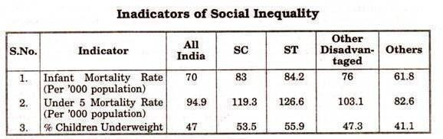

Social Inequality:
The growth of health facilities has been highly imbalanced in India. Rural, hilly and remote areas of the country are under served while in urban areas and cities, health facility is well developed. The SC/ST and the poor people are far away from modern health service.

The table shows social inequality in provision of health in India.

Shortage of Medical Personnel:
In India shortage of medical personnel like doctors, a nurse etc. is a basic problem in the health sector. In 1999-2000, while there were only 5.5 doctors per 10,000 population in India, the same is 25 in the USA and 20 in China. Similarly the number of hospitals and dispensaries is insufficient in comparison to our vast population.

Medical Research:
Medical research in the country needs to be focused on drugs and vaccines for tropical diseases which are normally neglected by international pharmaceutical companies on account of their limited profitability potential. The National Health Policy 2002 suggests to allocate more funds to boost medical research in this direction.

Expensive Health Service:
In India, health services especially allopathic are quite expensive. It hits hard the common man. Prices of various essential drugs have gone up. Therefore more emphasis should be givento the alternative systems of medicine. Ayurveda, Unani and Homeopathy systems are less costly and will serve the common man in better way. Concluding the health system has many problems. These problems can be overcome by effective planning and allocating more funds.

STEPS TO INCREASE HEALTH SERVICES
Improving medical facilities in rural areas is crucial to ensure that people living in remote areas have access to quality healthcare services. Here are some measures that can help to improve medical facilities in rural areas:
  - Building and upgrading healthcare infrastructure: This includes constructing new hospitals, health centers, and clinics, as well as renovating and upgrading existing ones. This will help to improve the availability and quality of medical facilities in rural areas.

  - Recruiting and training more healthcare professionals: Rural areas often suffer from a shortage of doctors, nurses, and other healthcare professionals. Governments can provide incentives to attract healthcare professionals to rural areas and provide training programs to upgrade their skills

  - Providing telemedicine facilities: Telemedicine can be used to connect rural healthcare facilities with urban hospitals, allowing doctors and specialists to remotely diagnose and treat patients in rural areas. This can help to improve the quality of healthcare services in rural areas

  - Providing medical equipment and supplies: Rural healthcare facilities often lack adequate medical equipment and supplies. Providing them with essential medical equipment such as x-ray machines, ultrasound machines, and laboratory equipment can improve the quality of healthcare services provided in rural areas.

  - Encouraging public-private partnerships: Governments can encourage private organizations to invest in rural healthcare facilities by providing tax incentives or other benefits. This can help to improve the quality and accessibility of healthcare services in rural areas.

  - Awareness campaigns: Conducting awareness campaigns on public health issues and encouraging people to seek medical attention can help improve health outcomes in rural areas. This includes educating people on preventive measures for common illnesses, such as vaccination campaigns, sanitation, and hygiene practices.

  - Encouraging local healthcare solutions: In many cases, rural communities have their own traditional healthcare practices. Governments can work with local healthcare providers to integrate these practices into the formal healthcare system and improve the quality of care provided to rural communities.

CHAPTER6: RECOMMENDATIONS AND CONCLUSIONS OF THE MINI PROJECT
We recommend the following ways to increase Health facilities in rural areas:

Collaborating with Larger Healthcare Networks
Byaffiliating with larger healthcare systems in more urban settings, rural healthcare facilities can improve health care in rural communities by offering their patients improved infrastructure and resources that are more financially viable. Collaborating with larger healthcare organizations can also bring more specialized and expansive healthcare services to rural areas. A report published by the RUPRI Center for Rural Health Policy notes a trend of rural hospitals increasing their affiliation with other hospital systems. The report offers several benefits rural hospitals can receive by collaborating with other hospital systems, such as:

- Improved technology
- Improved performance and services
- Greater flexibility in payment models
- Larger recruiting and retention efforts for staff

Through collaboration with larger legacy institutions, smaller healthcare facilitiescan lower their costs and increase their reach in rural communities.

Telehealth
Another solution for increasing access to health care in rural areas is through telehealth. Telehealth can include videoconferencing, streaming media, and cellular communication to administer and support a patient’s health. Telehealth has seen significant growth since the start of COVID-19 and will likely remain a vital aspect of the health industry going forward.
The kind of care one can access with telehealth includes:

- Mental health treatment such as therapy and counseling
- Treating skin conditions
- Reviewing urgent care issues such as colds, coughs, and stomach bugs
- Post-surgical follow-ups
- Monitoring services for chronic conditions like high blood pressure, high cholesterol,and diabetes

Mobile Health Care

These “clinics on wheels” can help solve the issue of transportation many rural citizens face. Mobile health clinics are also significantly less expensive for both patients and providers as the infrastructure costs are dramatically reduced.
While offering potential cost savings to patients and insurers, mobile clinics can also assist in building relationships and increasing health literacy in rural areas for women and minorities. A study published in the International Journal of Equity in Health conducted in 2020, which reviewed several mobile healthcare initiatives, found that over half of mobile healthcare clients are women (55 percent) and racial/ethnic minorities (59 percent). Most of those who received care were either uninsured or had some form of public insurance. The majority of these mobile clinics received some form of financial support from philanthropy.

Student Self-Evaluation for the Community Service Project
Student Name : K.Sai Surendra
Registration No: 23761A0522
Period Of CSP : From : 01-06-2025 To 13-07-2025
Date of Evaluation:

Please rate our performance in the following areas:
Rating Scale: Letter grade of CGPA calculation to be provided

1 | Oral communication | 1 | 2 | 3 | 4 | 5
2 | Written communication | 1 | 2 | 3 | 4 | 5
3 | Proactiveness | 1 | 2 | 3 | 4 | 5
4 | Interaction ability with community | 1 | 2 | 3 | 4 | 5
5 | Positive Attitude | 1 | 2 | 3 | 4 | 5
6 | Self-confidence | 1 | 2 | 3 | 4 | 5
7 | Ability to learn | 1 | 2 | 3 | 4 | 5
8 | Work Plan and organization | 1 | 2 | 3 | 4 | 5
9 | Professionalism | 1 | 2 | 3 | 4 | 5
10 | Creativity | 1 | 2 | 3 | 4 | 5
11 | Quality of work done | 1 | 2 | 3 | 4 | 5
12 | Time Management | 1 | 2 | 3 | 4 | 5
13 | Understanding the Community | 1 | 2 | 3 | 4 | 5
14 | Achievement of Desired Outcomes | 1 | 2 | 3 | 4 | 5
15 | OVERALL PERFORMANCE | 1 | 2 | 3 | 4 | 5

Date: Signature of the Student

Student Self-Evaluation for the Community Service Project
Student Name : K.Anirudh
Registration No: 23761A0523
Period Of CSP : From : 01-06-2025 To 13-07-2025
Date of Evaluation:

Please rate our performance in the following areas:
Rating Scale: Letter grade of CGPA calculation to be provided

1 | Oral communication | 1 | 2 | 3 | 4 | 5
2 | Written communication | 1 | 2 | 3 | 4 | 5
3 | Proactiveness | 1 | 2 | 3 | 4 | 5
4 | Interaction ability with community | 1 | 2 | 3 | 4 | 5
5 | Positive Attitude | 1 | 2 | 3 | 4 | 5
6 | Self-confidence | 1 | 2 | 3 | 4 | 5
7 | Ability to learn | 1 | 2 | 3 | 4 | 5
8 | Work Plan and organization | 1 | 2 | 3 | 4 | 5
9 | Professionalism | 1 | 2 | 3 | 4 | 5
10 | Creativity | 1 | 2 | 3 | 4 | 5
11 | Quality of work done | 1 | 2 | 3 | 4 | 5
12 | Time Management | 1 | 2 | 3 | 4 | 5
13 | Understanding the Community | 1 | 2 | 3 | 4 | 5
14 | Achievement of Desired Outcomes | 1 | 2 | 3 | 4 | 5
15 | OVERALL PERFORMANCE | 1 | 2 | 3 | 4 | 5

Date: Signature of the Student

Student Self-Evaluation for the Community Service Project
Student Name : K.Kavya
Registration No: 23761A0524
Period Of CSP : From : 01-06-2025 To 13-07-2025
Date of Evaluation:

Please rate our performance in the following areas:
Rating Scale: Letter grade of CGPA calculation to be provided

1 | Oral communication | 1 | 2 | 3 | 4 | 5
2 | Written communication | 1 | 2 | 3 | 4 | 5
3 | Proactiveness | 1 | 2 | 3 | 4 | 5
4 | Interaction ability with community | 1 | 2 | 3 | 4 | 5
5 | Positive Attitude | 1 | 2 | 3 | 4 | 5
6 | Self-confidence | 1 | 2 | 3 | 4 | 5
7 | Ability to learn | 1 | 2 | 3 | 4 | 5
8 | Work Plan and organization | 1 | 2 | 3 | 4 | 5
9 | Professionalism | 1 | 2 | 3 | 4 | 5
10 | Creativity | 1 | 2 | 3 | 4 | 5
11 | Quality of work done | 1 | 2 | 3 | 4 | 5
12 | Time Management | 1 | 2 | 3 | 4 | 5
13 | Understanding the Community | 1 | 2 | 3 | 4 | 5
14 | Achievement of Desired Outcomes | 1 | 2 | 3 | 4 | 5
15 | OVERALL PERFORMANCE | 1 | 2 | 3 | 4 | 5

Date: Signature of the Student

Student Self-Evaluation for the Community Service Project
Student Name : K.Mohan Maruthi
Registration No: 23761A0525
Period Of CSP : From : 01-06-2025 To 13-07-2025
Date of Evaluation:

Please rate our performance in the following areas:
Rating Scale: Letter grade of CGPA calculation to be provided

1 | Oral communication | 1 | 2 | 3 | 4 | 5
2 | Written communication | 1 | 2 | 3 | 4 | 5
3 | Proactiveness | 1 | 2 | 3 | 4 | 5
4 | Interaction ability with community | 1 | 2 | 3 | 4 | 5
5 | Positive Attitude | 1 | 2 | 3 | 4 | 5
6 | Self-confidence | 1 | 2 | 3 | 4 | 5
7 | Ability to learn | 1 | 2 | 3 | 4 | 5
8 | Work Plan and organization | 1 | 2 | 3 | 4 | 5
9 | Professionalism | 1 | 2 | 3 | 4 | 5
10 | Creativity | 1 | 2 | 3 | 4 | 5
11 | Quality of work done | 1 | 2 | 3 | 4 | 5
12 | Time Management | 1 | 2 | 3 | 4 | 5
13 | Understanding the Community | 1 | 2 | 3 | 4 | 5
14 | Achievement of Desired Outcomes | 1 | 2 | 3 | 4 | 5
15 | OVERALL PERFORMANCE | 1 | 2 | 3 | 4 | 5

Date: Signature of the Student

Student Self-Evaluation for the Community Service Project
Student Name : K.Gopichand
Registration No: 23761A0526
Period Of CSP : From : 01-06-2025 To 13-07-2025
Date of Evaluation:

Please rate our performance in the following areas:
Rating Scale: Letter grade of CGPA calculation to be provided

1 | Oral communication | 1 | 2 | 3 | 4 | 5
2 | Written communication | 1 | 2 | 3 | 4 | 5
3 | Proactiveness | 1 | 2 | 3 | 4 | 5
4 | Interaction ability with community | 1 | 2 | 3 | 4 | 5
5 | Positive Attitude | 1 | 2 | 3 | 4 | 5
6 | Self-confidence | 1 | 2 | 3 | 4 | 5
7 | Ability to learn | 1 | 2 | 3 | 4 | 5
8 | Work Plan and organization | 1 | 2 | 3 | 4 | 5
9 | Professionalism | 1 | 2 | 3 | 4 | 5
10 | Creativity | 1 | 2 | 3 | 4 | 5
11 | Quality of work done | 1 | 2 | 3 | 4 | 5
12 | Time Management | 1 | 2 | 3 | 4 | 5
13 | Understanding the Community | 1 | 2 | 3 | 4 | 5
14 | Achievement of Desired Outcomes | 1 | 2 | 3 | 4 | 5
15 | OVERALL PERFORMANCE | 1 | 2 | 3 | 4 | 5

Date: Signature of the Student

Evaluation by the Person in-charge in the Community / Habitation
Student Name: Registration No:
Period of CSP: From: To : Date of Evaluation:
Name of the Person in-charge: Address with mobile number:
Please rate the student’s performance in the following areas:

Please note that your evaluation shall be done independent of the Student’s self-evaluation

Rating Scale: 1 is lowest and 5 is highest rank

1 | Oral communication | 1 | 2 | 3 | 4 | 5
2 | Written communication | 1 | 2 | 3 | 4 | 5
3 | Proactiveness | 1 | 2 | 3 | 4 | 5
4 | Interaction ability with community | 1 | 2 | 3 | 4 | 5
5 | Positive Attitude | 1 | 2 | 3 | 4 | 5
6 | Self-confidence | 1 | 2 | 3 | 4 | 5
7 | Ability to learn | 1 | 2 | 3 | 4 | 5
8 | Work Plan and organization | 1 | 2 | 3 | 4 | 5
9 | Professionalism | 1 | 2 | 3 | 4 | 5
10 | Creativity | 1 | 2 | 3 | 4 | 5
11 | Quality of work done | 1 | 2 | 3 | 4 | 5
12 | Time Management | 1 | 2 | 3 | 4 | 5
13 | Understanding the Community | 1 | 2 | 3 | 4 | 5
14 | Achievement of Desired Outcomes | 1 | 2 | 3 | 4 | 5
15 | OVERALL PERFORMANCE | 1 | 2 | 3 | 4 | 5

Date: Signature of the Supervisor

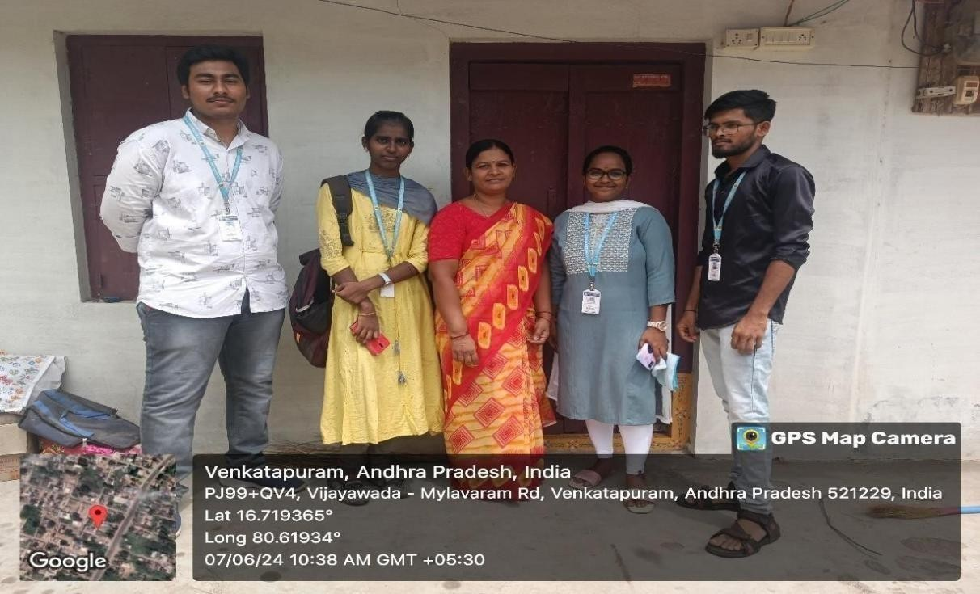
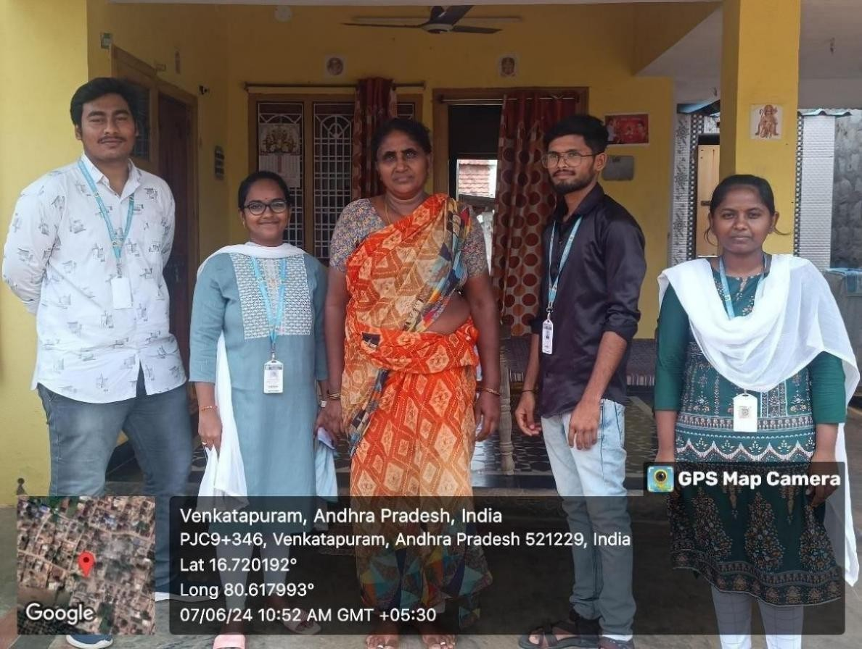

PHOTOS & VIDEOLINKS

Fig:1-surveying about Health care facilities in Venkatapuram

Fig -2: She is asking some better facilities like hospital near 10km

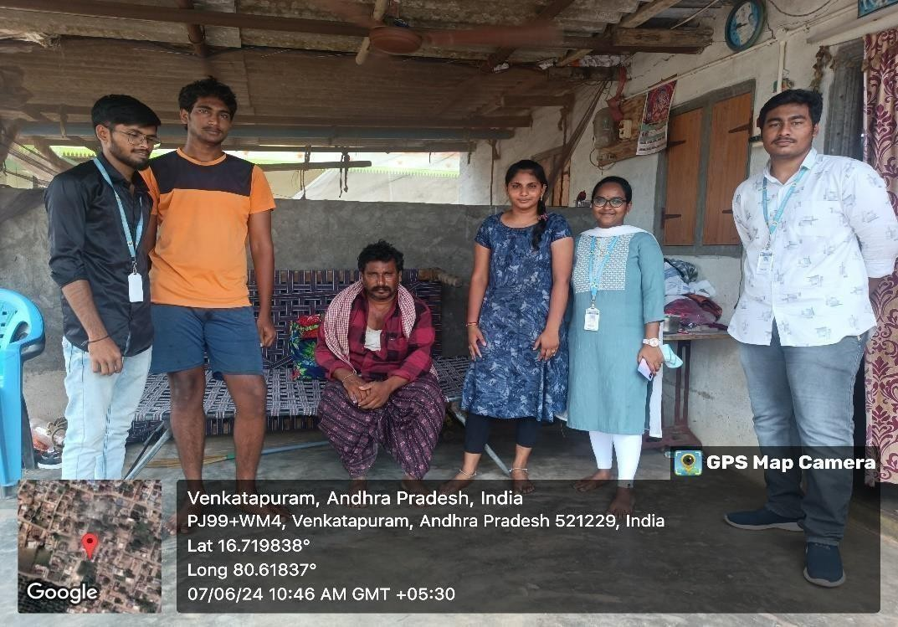
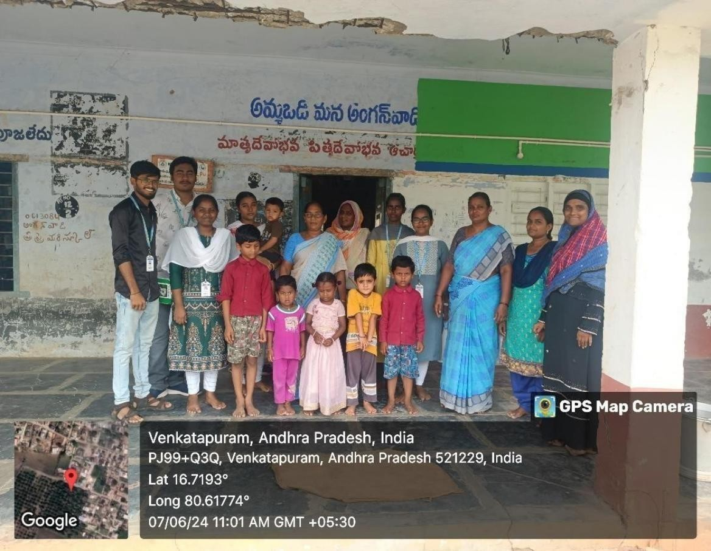

Fig-3:-Asked about the Health issues of the family

Fig-4:Went to the Anganvadi center in Venkatapuram Village

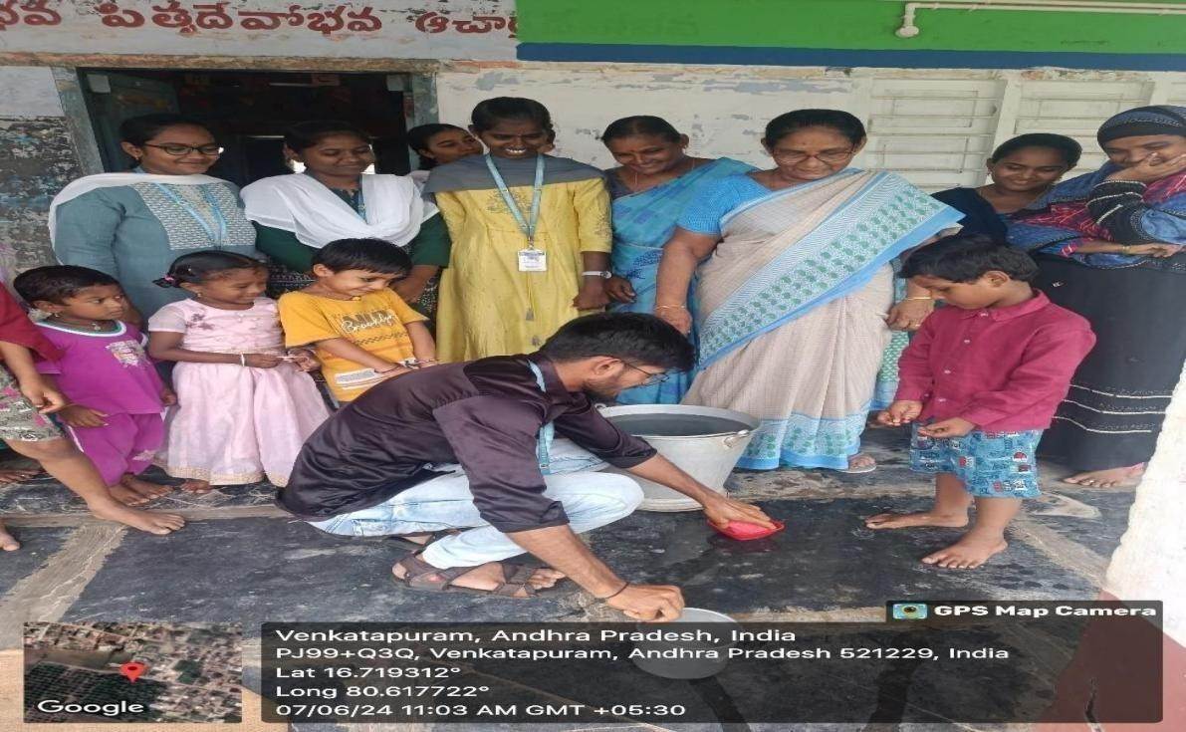
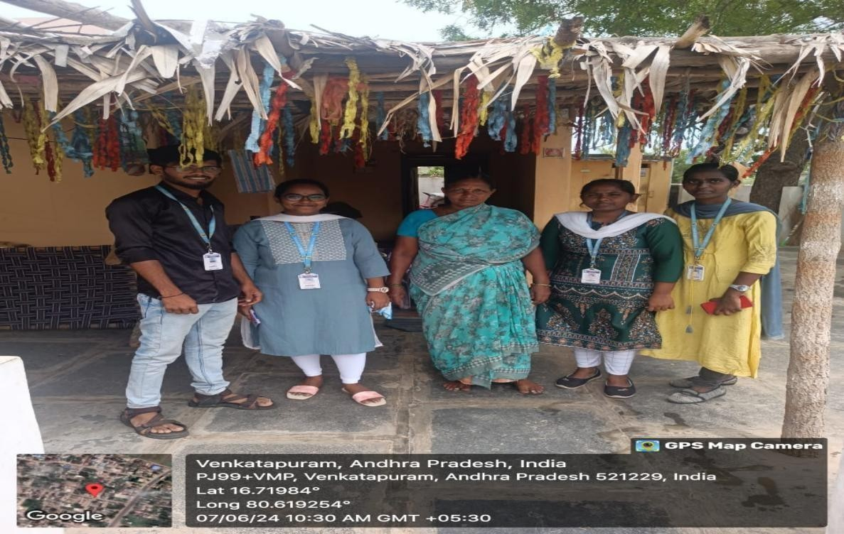

Fig-5:Our team member showed the hand sanitization methods to the childrens

Fig-6:Surveyed the house of farmer’s family

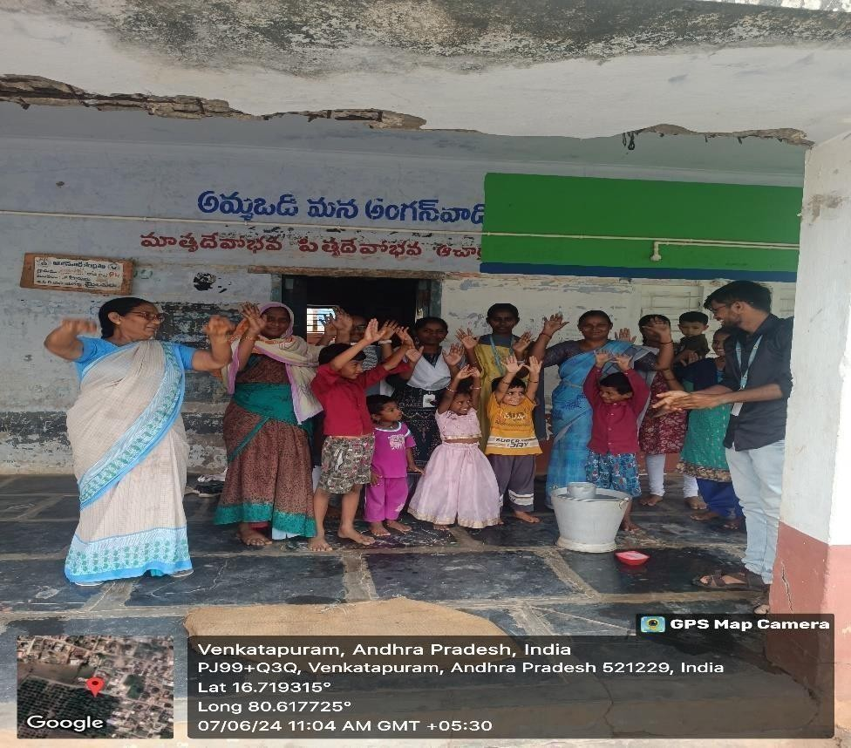
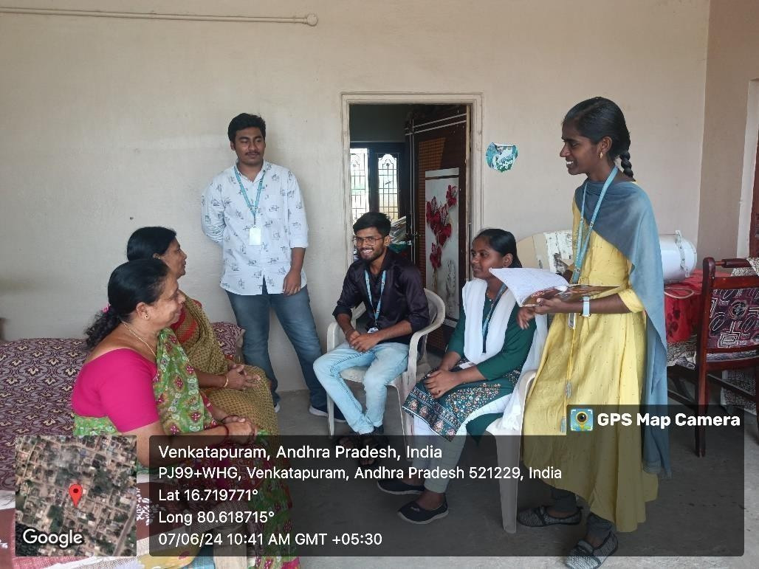

Fig-7:Childerns of anganvadi participated in our survey

Fig-8: Our team interacted and surveyed the elders of the family

REFERENCES LINKS

https://www.economicsdiscussion.net/articles/7-major-problems- of-health-services-in-india/2305
https://publichealth.tulane.edu/blog/how-to-improve-health-care- in-rural-areas/
https://www.personallydelivered.com/blog/the-importance-of- hygiene/

50

MARKS STATEMENT

(To be used by the Examiners)

INTERNAL ASSESSMENT STATEMENT

Name of the Student :K.SaiSurendra
Programme Of Study: B.Tech Year Of Study: 2nd year

Group: Computer Science And Engineering
Register No / H.T. No: 23761A0522

Name Of the College: Lakireddy Bali Reddy College Of Engineering
University: JNTUK

Sl.No | Evaluation Criterion | Maximum Marks | Marks Awarded
1. | Activity Log | 20
2. | Community Service Project Implementation | 30
3. | Mini Project Work | 25
4. | Oral Presentation | 25
 | GRANDTOTAL | 100

Date: Signature of the Faculty Guide

Certified by

Date: Signature of the Head of the Department/Principal Seal:

INTERNAL ASSESSMENT STATEMENT
Name of the Student:K.Anirudh
Programme Of Study: B.Tech Year Of Study: 3rd year

Group: Computer Science And Engineering
Register No / H.T. No: 23761A0523

Name Of the College: Lakireddy Bali Reddy College Of Engineering

University: JNTUK

Sl.No | Evaluation Criterion | Maximum Marks | Marks Awarded
1. | Activity Log | 20
2. | Community Service Project Implementation | 30
3. | Mini Project Work | 25
4. | Oral Presentation | 25
 | GRANDTOTAL | 100

Date: Signature of the Faculty Guide

Certified by

Date: Signature of the Head of the Department/Principal Seal:

INTERNAL ASSESSMENT STATEMENT
Name of the Student: K.Kavya
Programme Of Study: B.Tech Year Of Study: 2nd year

Group: Computer Science And Engineering
Register No / H.T. No: 23761A0524

Name Of the College: Lakireddy Bali Reddy College Of Engineering
University: JNTUK

Sl.No | Evaluation Criterion | Maximum Marks | Marks Awarded
1. | Activity Log | 20
2. | Community Service Project Implementation | 30
3. | Mini Project Work | 25
4. | Oral Presentation | 25
 | GRANDTOTAL | 100

Date: Signature of the Faculty Guide

Certified by

Date: Signature of the Head of the Department/Principal

Seal:

INTERNAL ASSESSMENT STATEMENT
Name of the Student: K.Mohan Maruthi
Programme Of Study: B.Tech
Year Of Study: 2nd year

Group: Computer Science And Engineering
Register No / H.T. No: 23761A0525

Name Of the College: Lakireddy Bali Reddy College Of Engineering
University: JNTUK

Sl.No | Evaluation Criterion | Maximum Marks | Marks Awarded
1. | Activity Log | 20
2. | Community Service Project Implementation | 30
3. | Mini Project Work | 25
4. | Oral Presentation | 25
 | GRANDTOTAL | 100

Date: Signature of the Faculty Guide

Certified by

Date: Signature of the Head of the Department/Principal

Seal:

INTERNAL ASSESSMENT STATEMENT
Name of the Student: K Gopichand
Programme Of Study: B.Tech
Year Of Study: 2nd year

Group: Computer Science And Engineering
Register No / H.T. No: 23761A0526
Name Of the College: Lakireddy Bali Reddy College Of Engineering

University: JNTUK

Sl.No | Evaluation Criterion | Maximum Marks | Marks Awarded
1. | Activity Log | 20
2. | Community Service Project Implementation | 30
3. | Mini Project Work | 25
4. | Oral Presentation | 25
 | GRANDTOTAL | 100

Date: Signature of the Faculty Guide

Certified by

Date: Signature of the Head of the Department/Principal

Seal:

